***LAB - 20***

Demo on Lambda Function with API Gateway

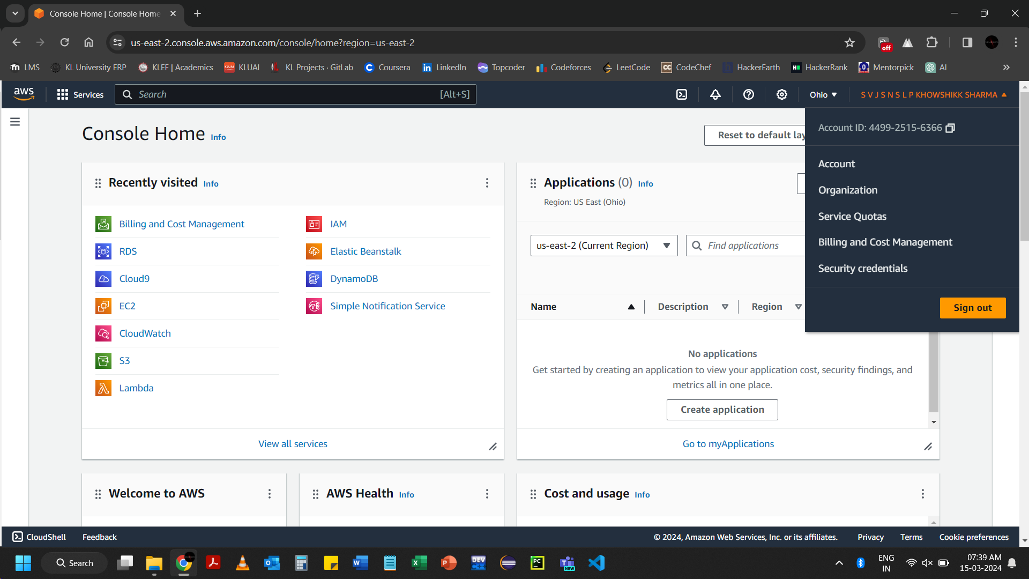

Go to AWS Lambda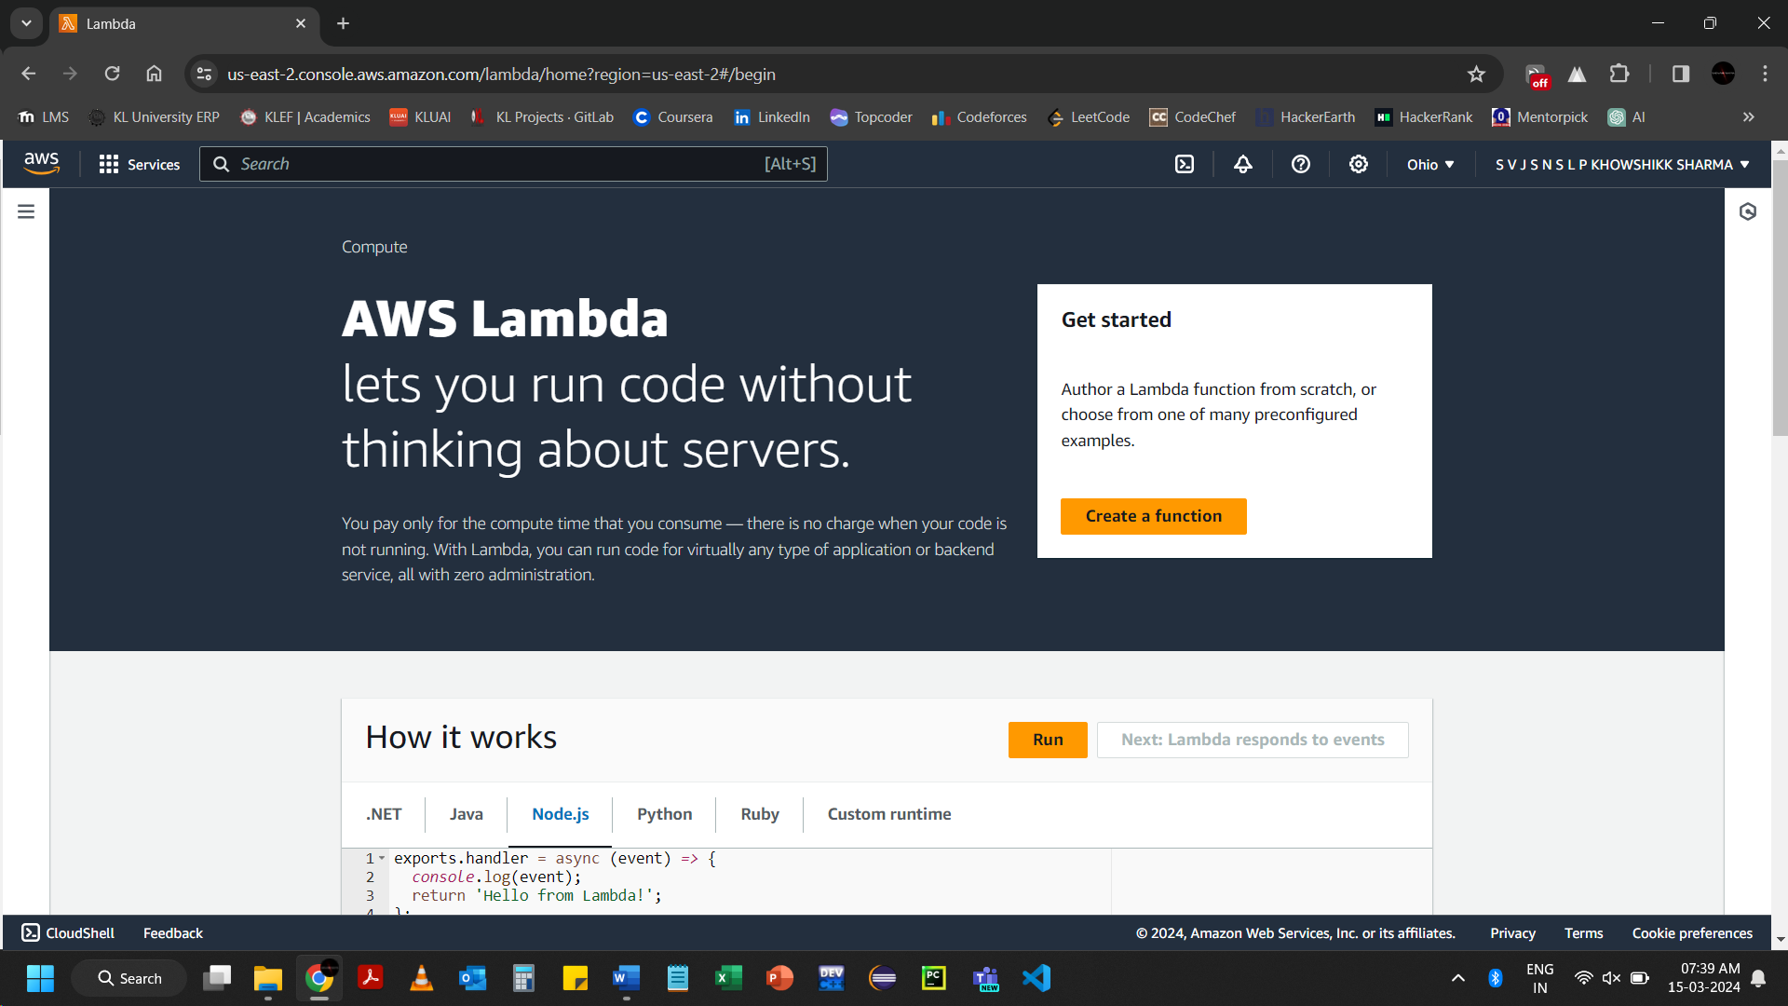Click on Create a function

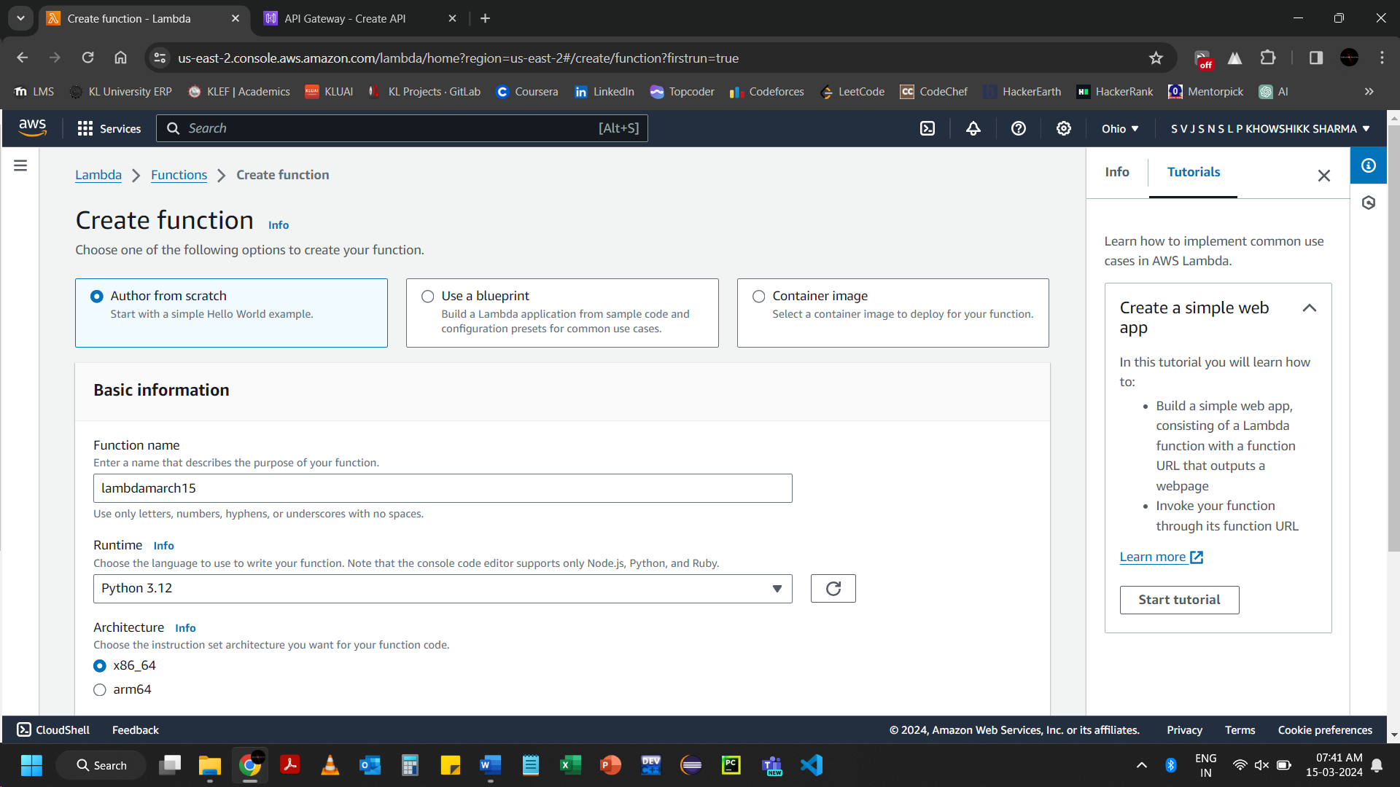

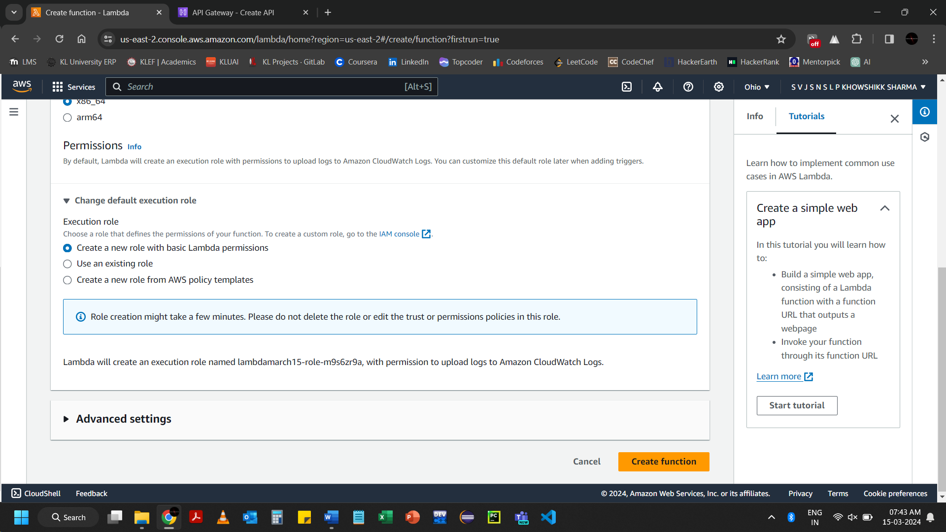Click on Create function

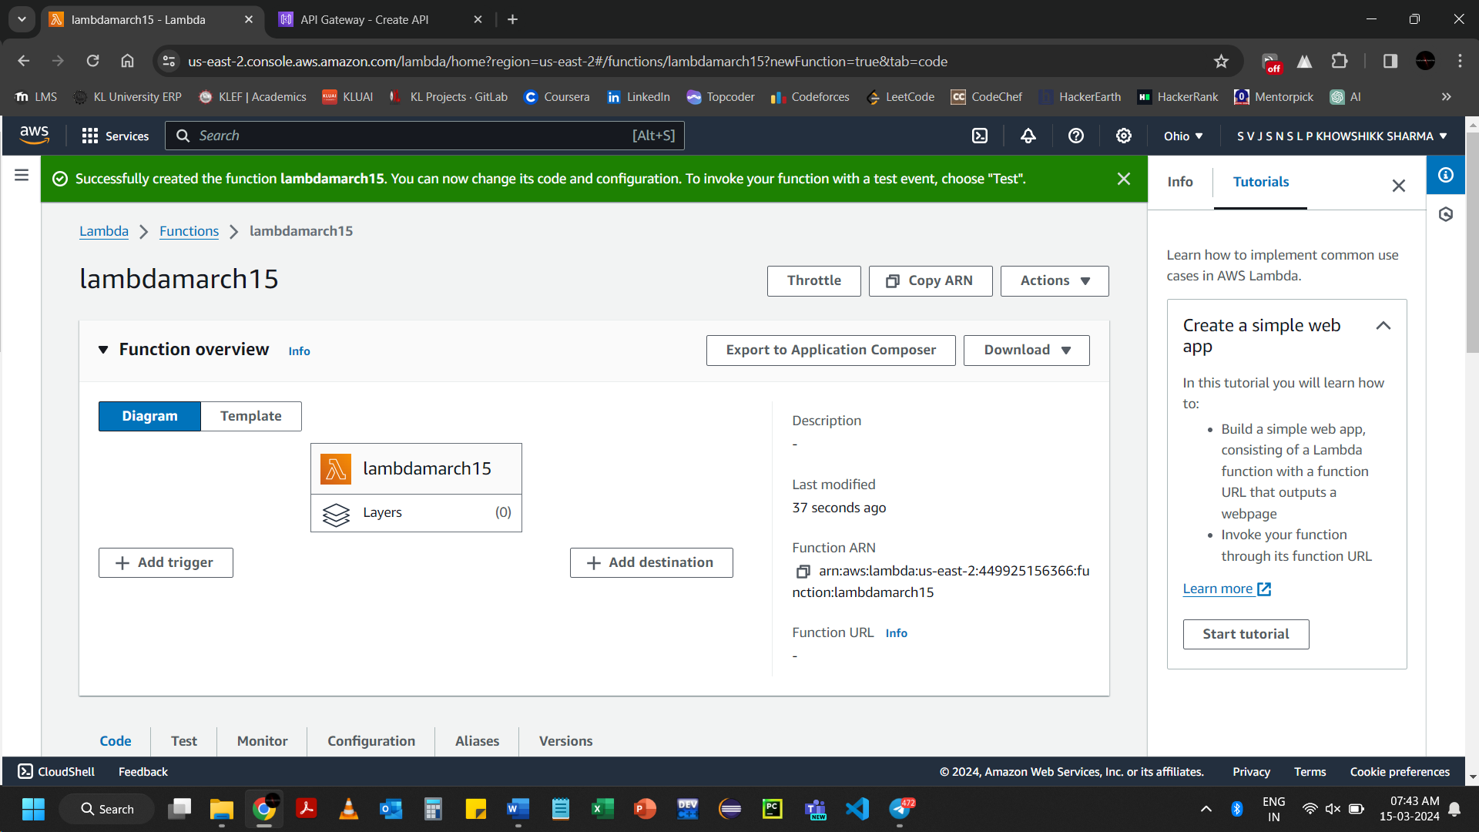

Go to API Gateway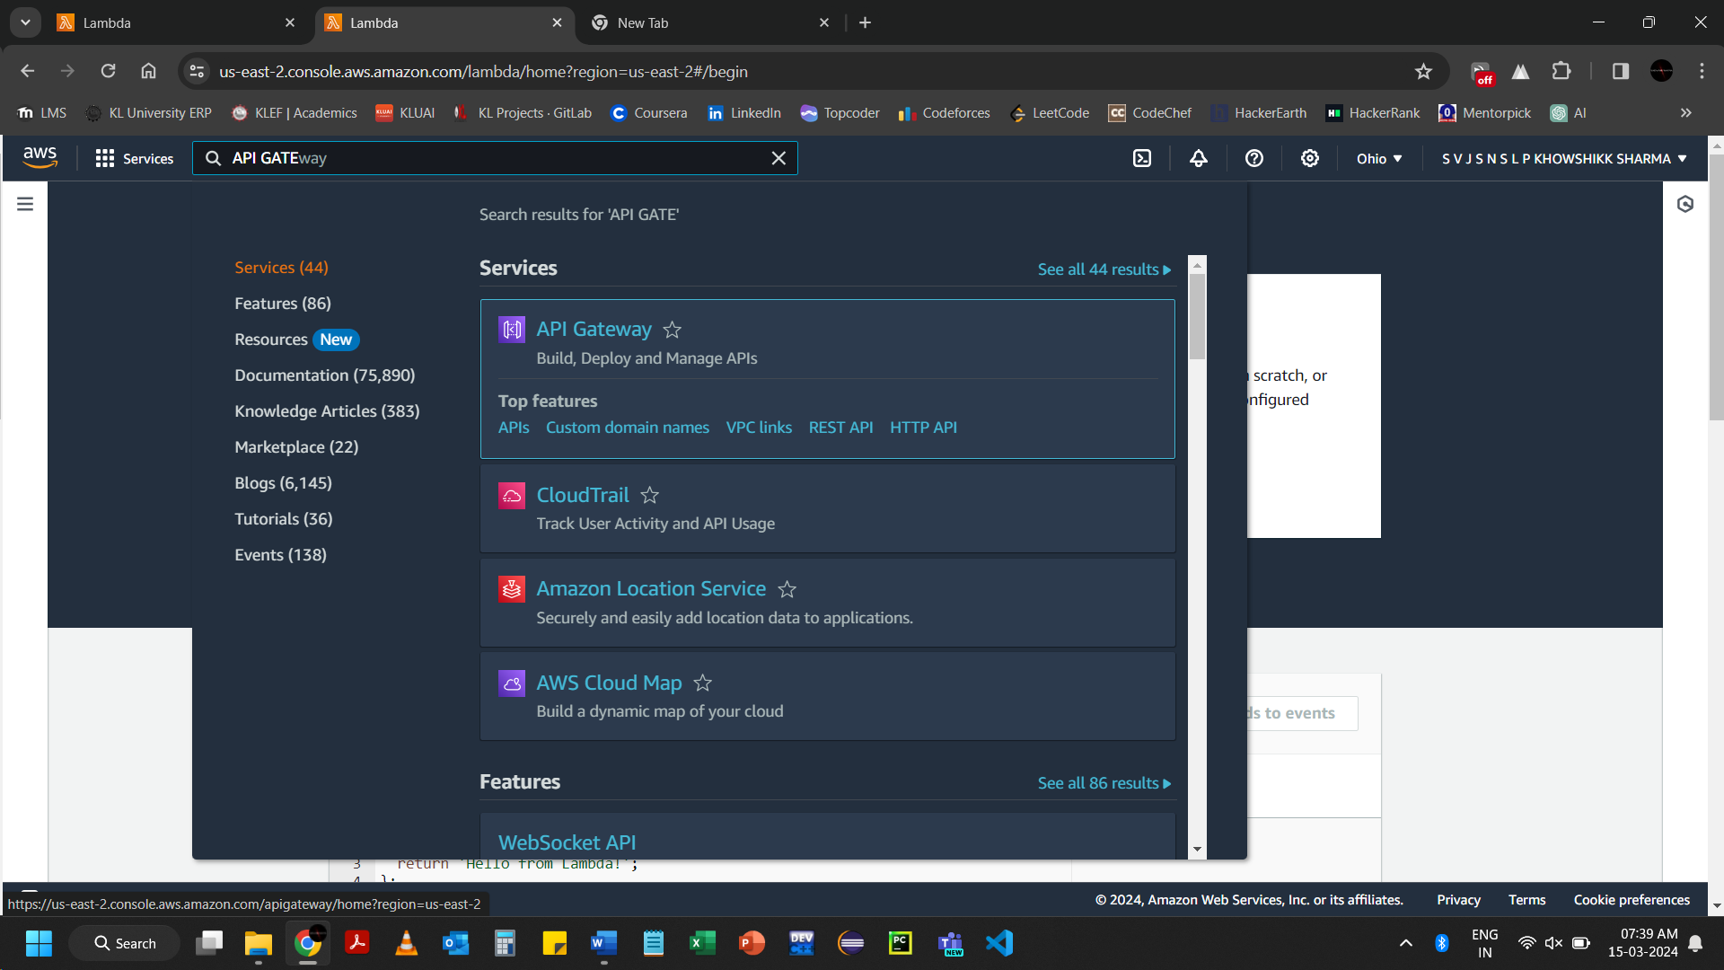

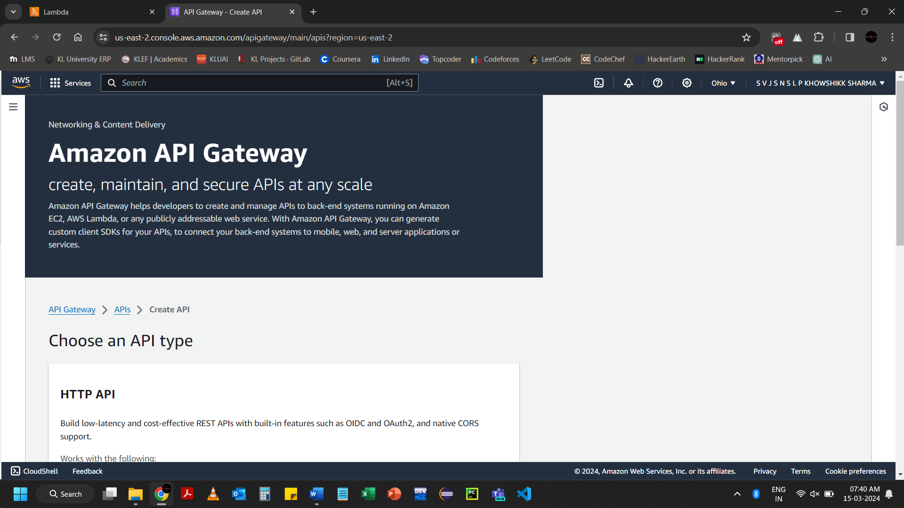

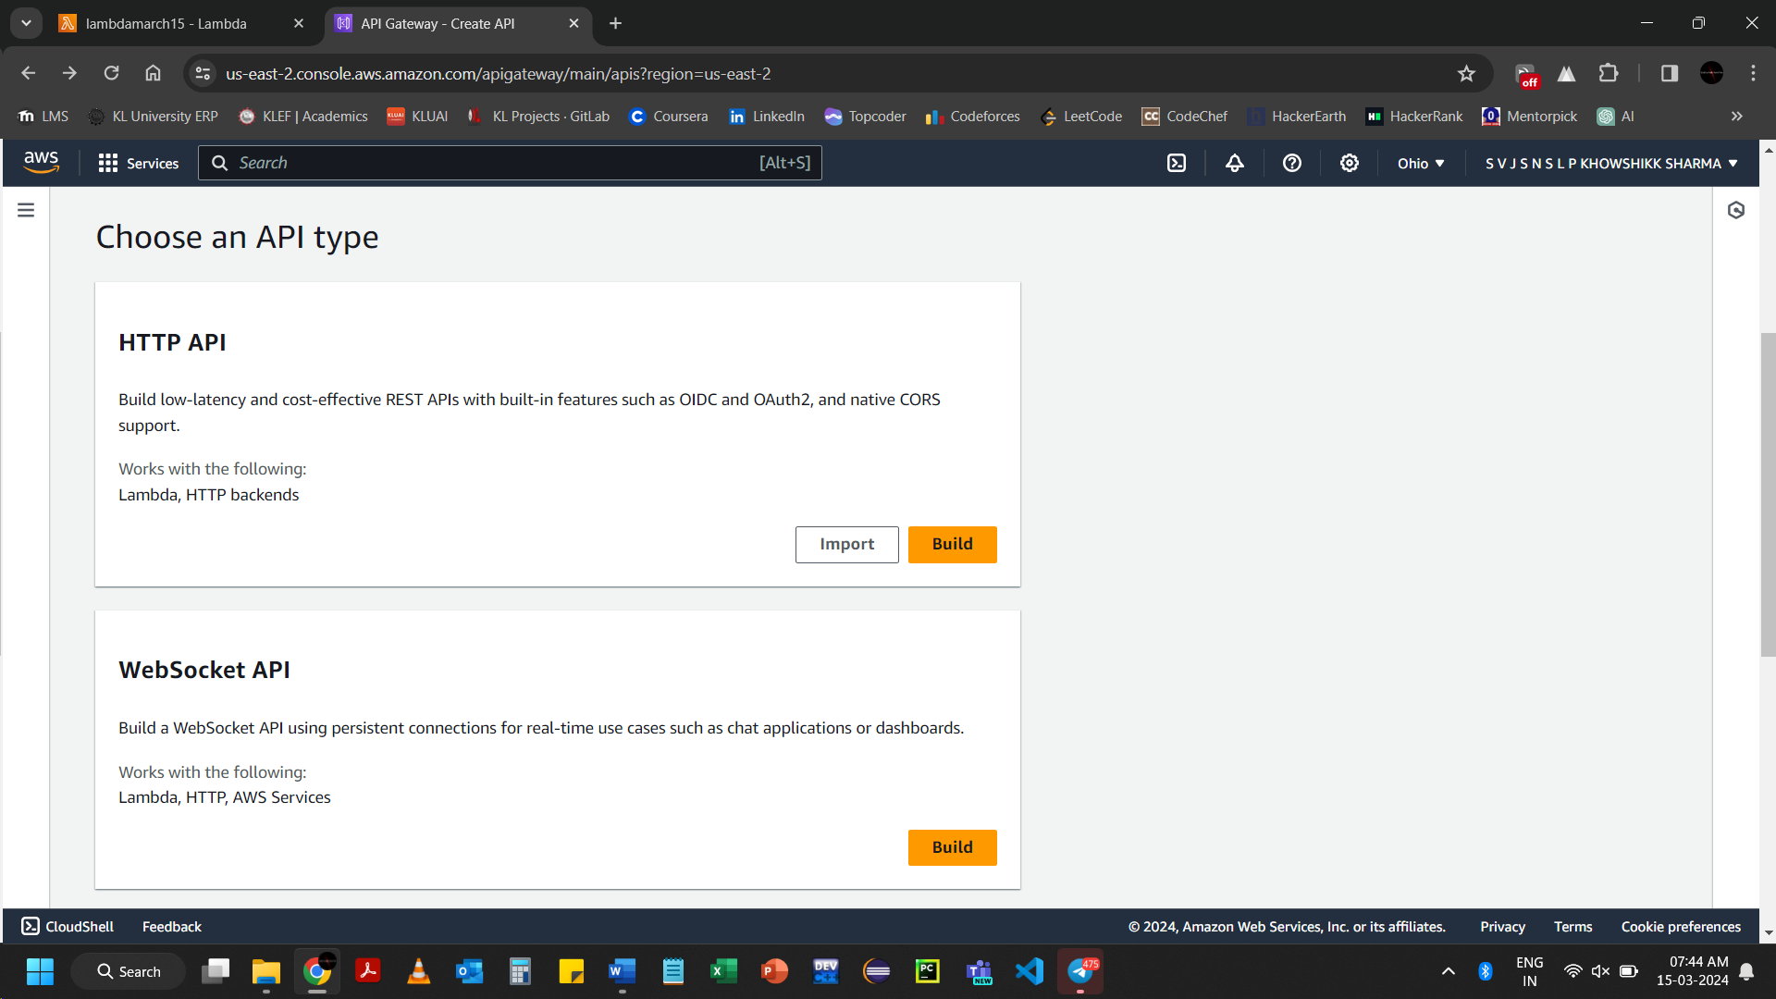Click on HTTP API 🡪 Build

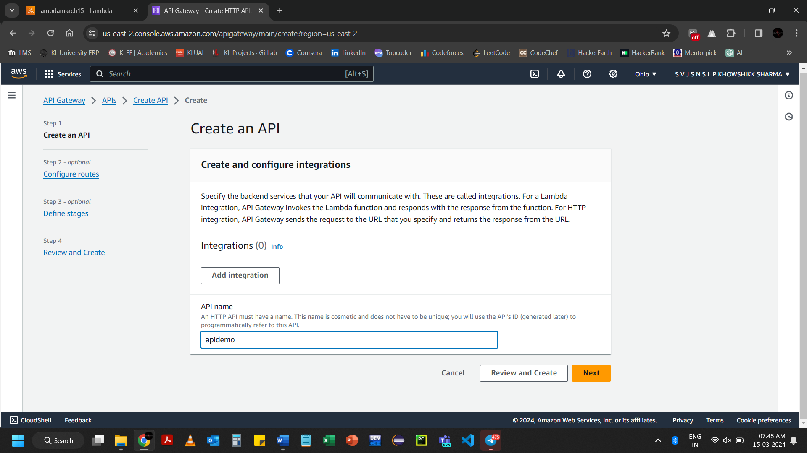Click on Next

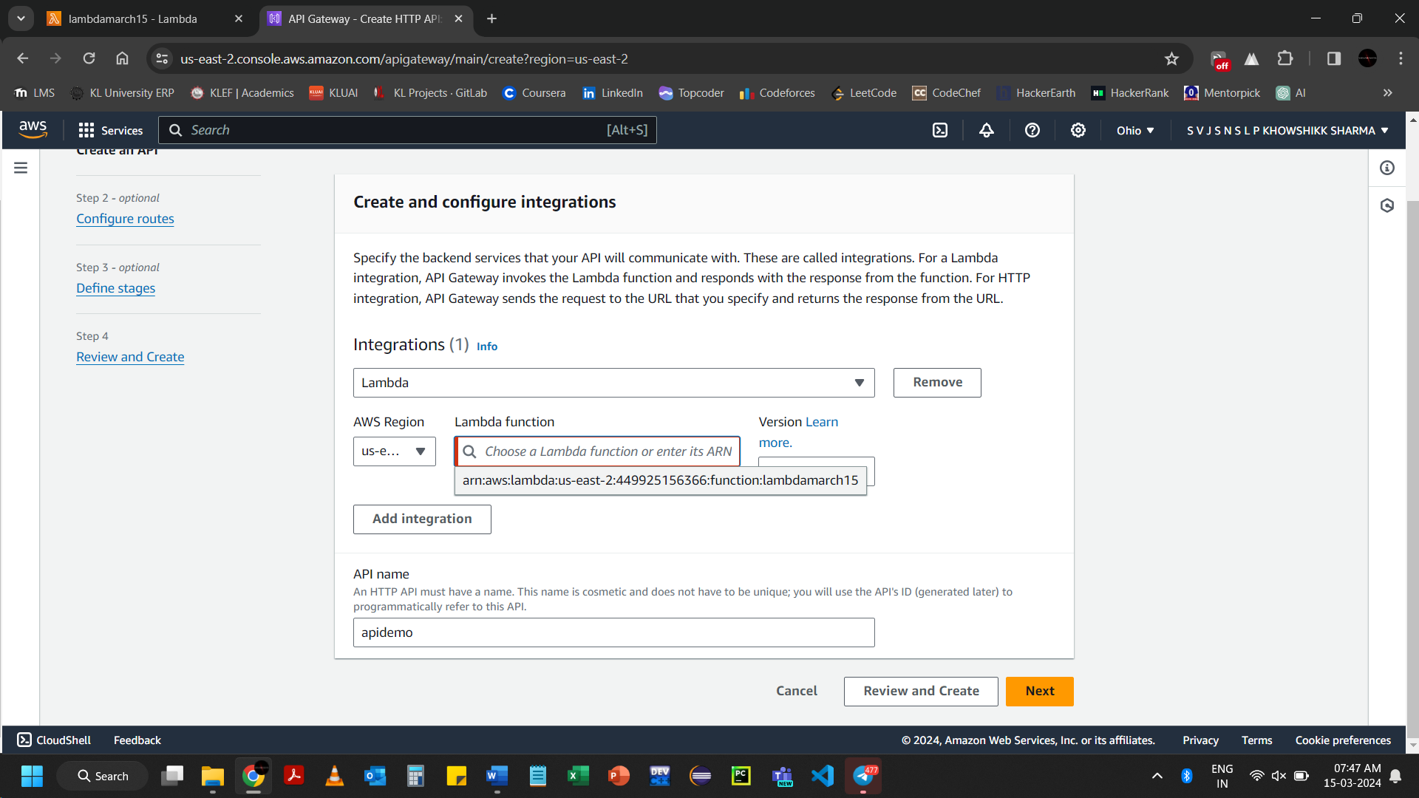Select the Lambda function, which is created for Connection

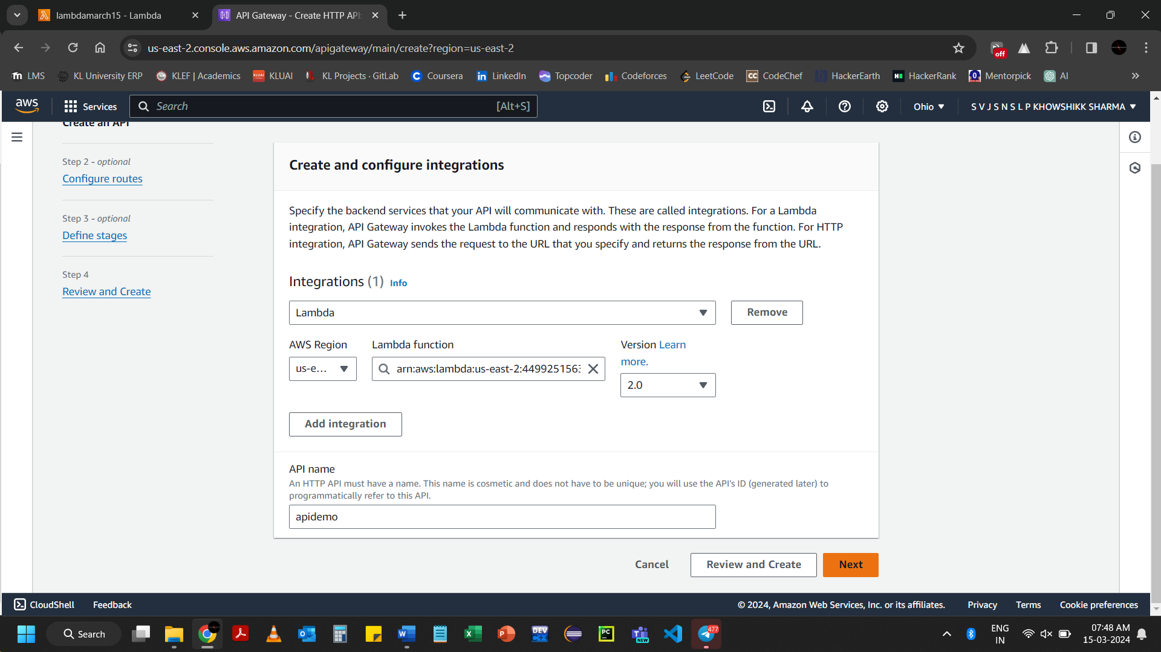 Click on Next

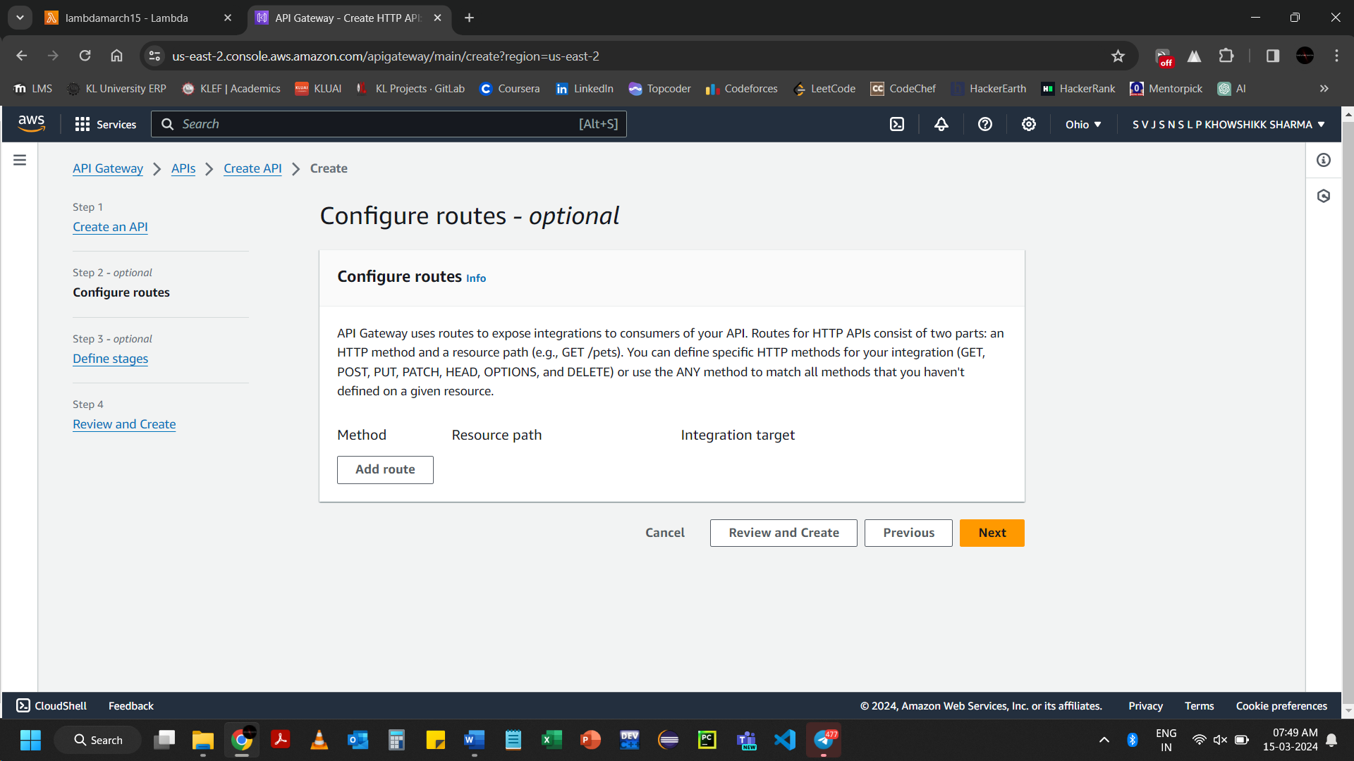Click on Add route 🡪 Select the Integrated target

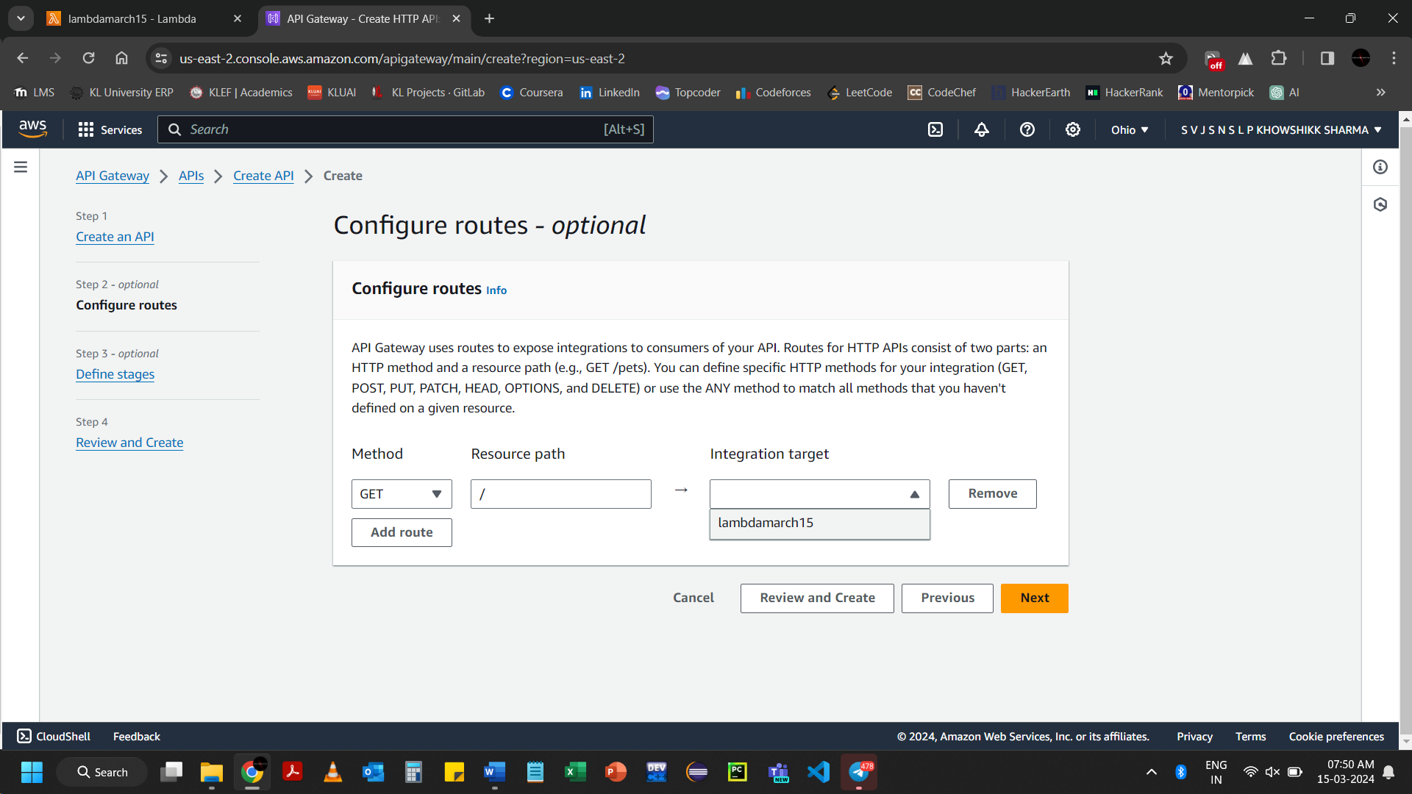 Select the Integrated target

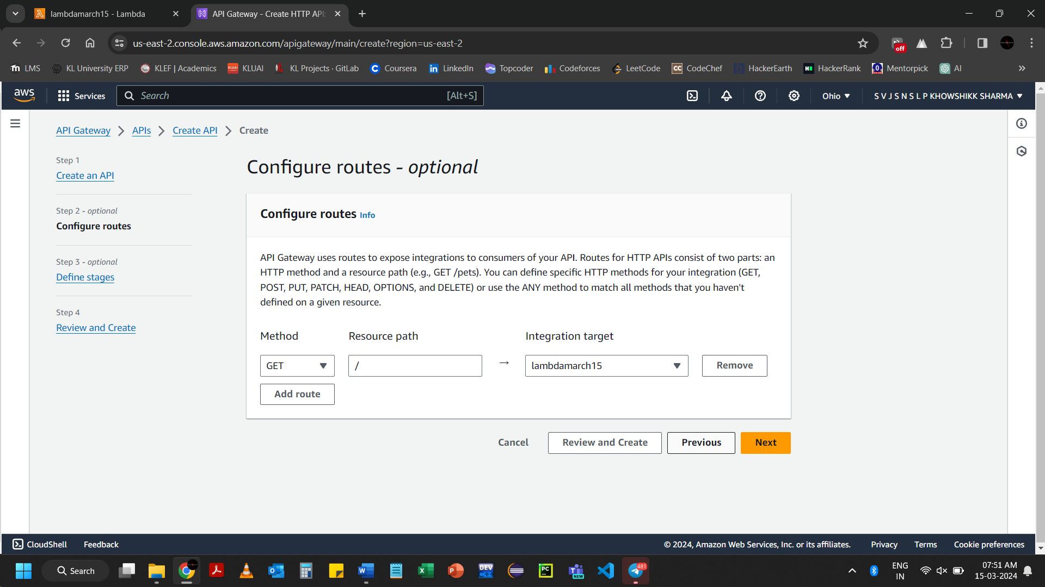 Click on Next

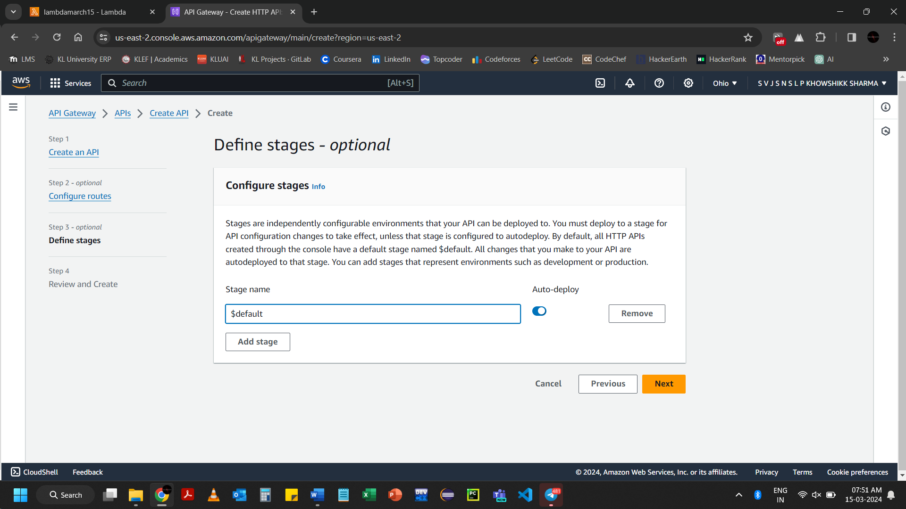 Click on Next

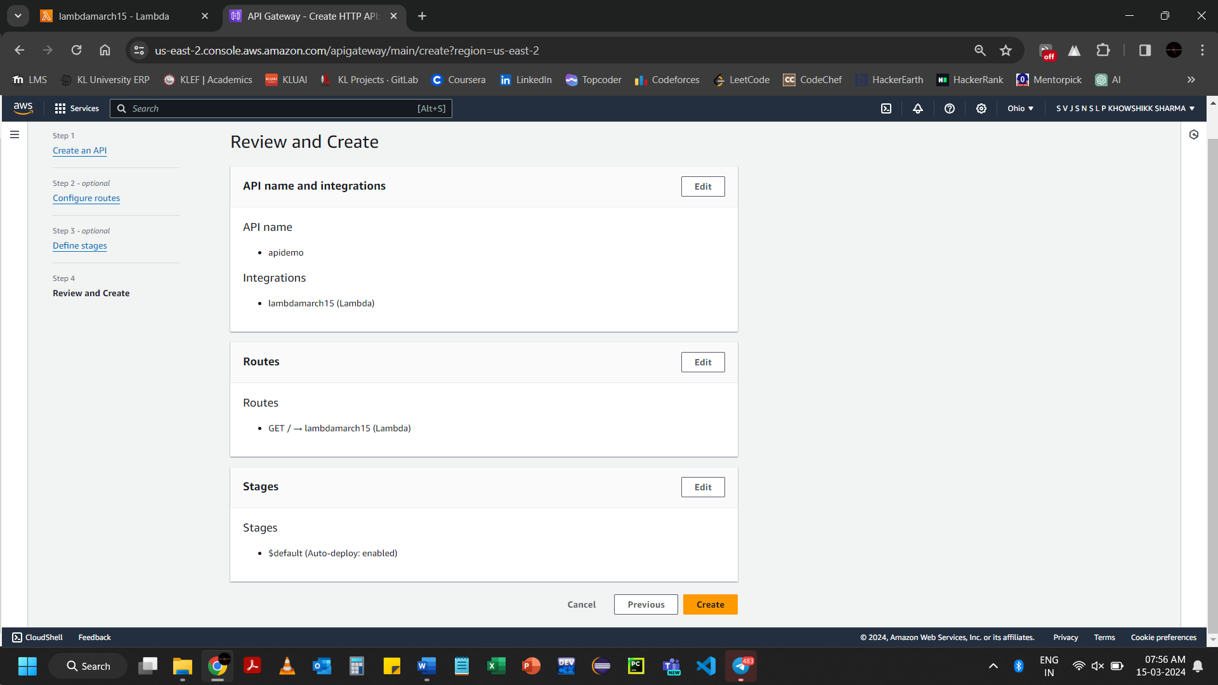 Click on Create

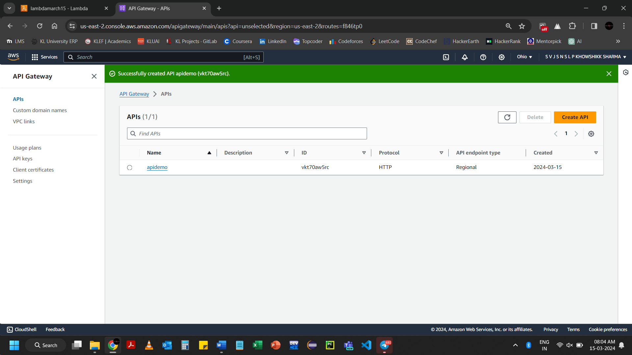

Go to API Gateway 🡪 APIs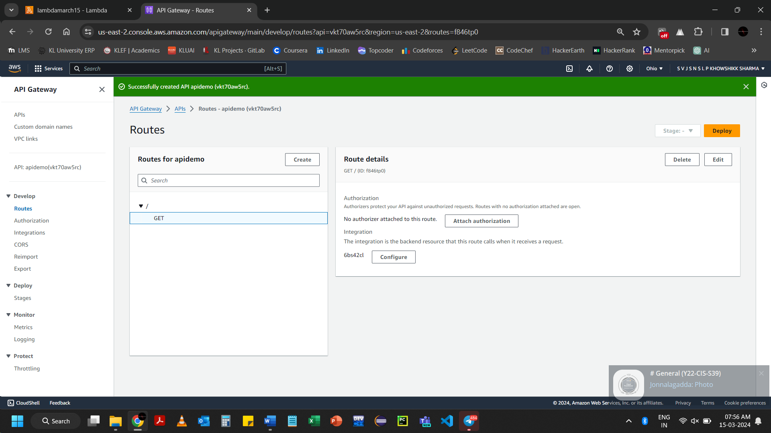

Go to API: apidemo(….)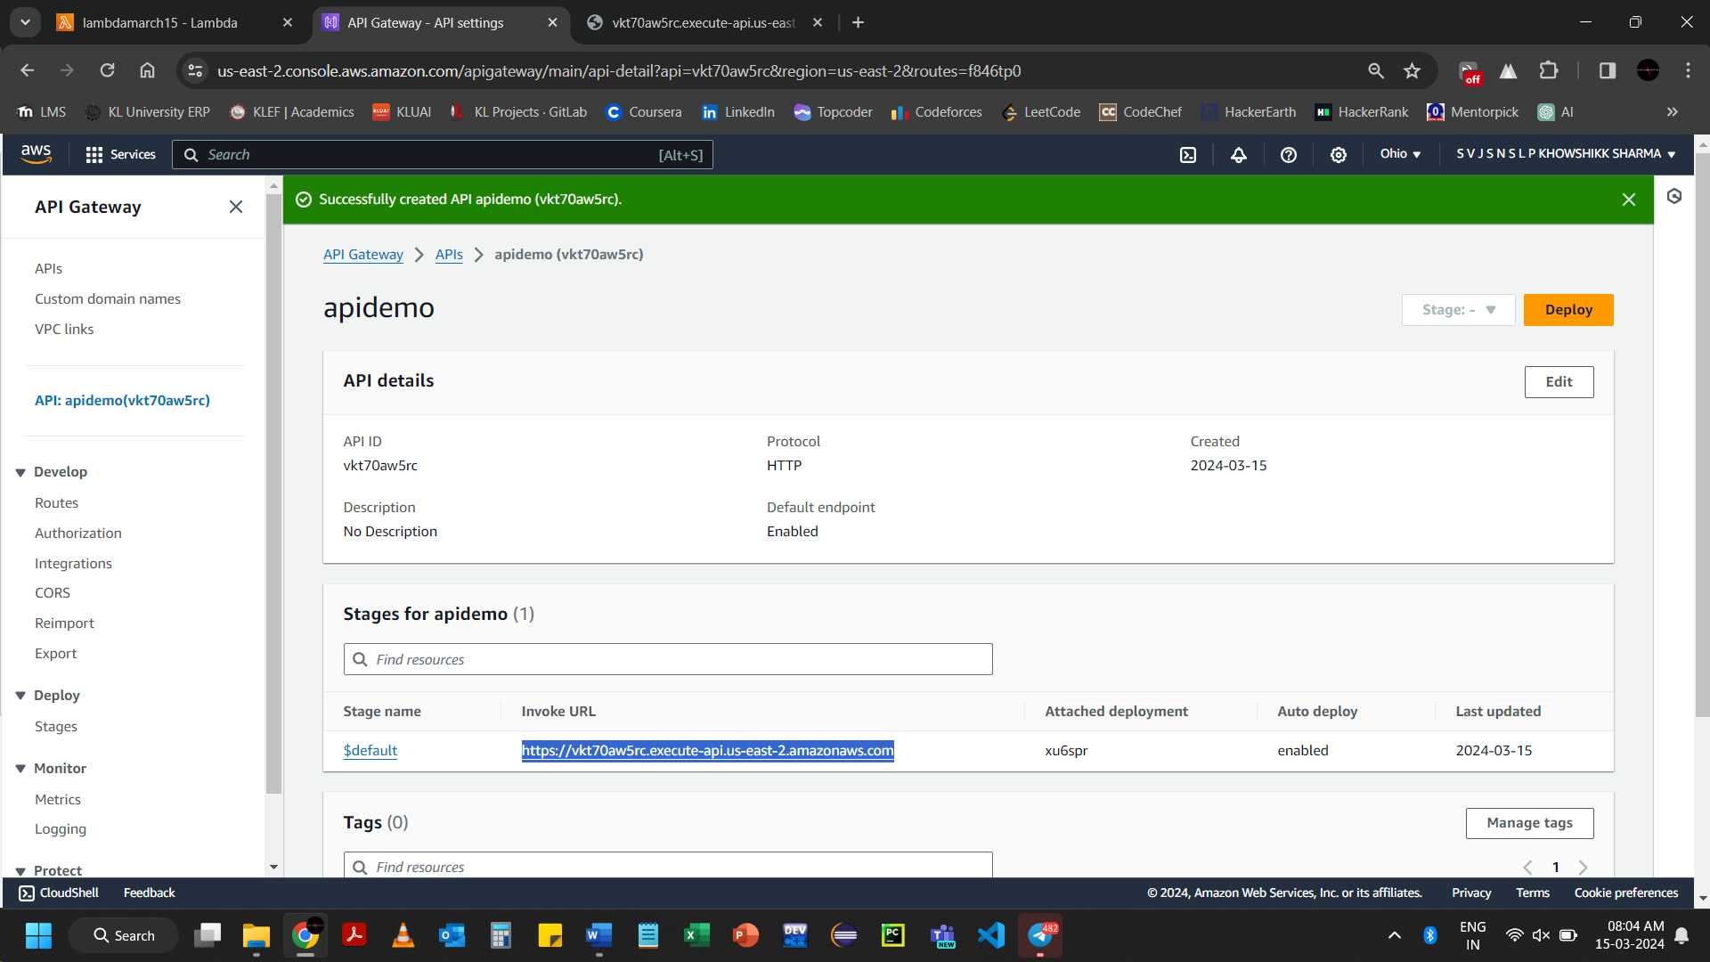Copy the URL which is highlighted

[https://vkt70aw5rc.execute-api.us-east-2.amazonaws.com](https://vkt70aw5rc.execute-api.us-east-2.amazonaws.com/)

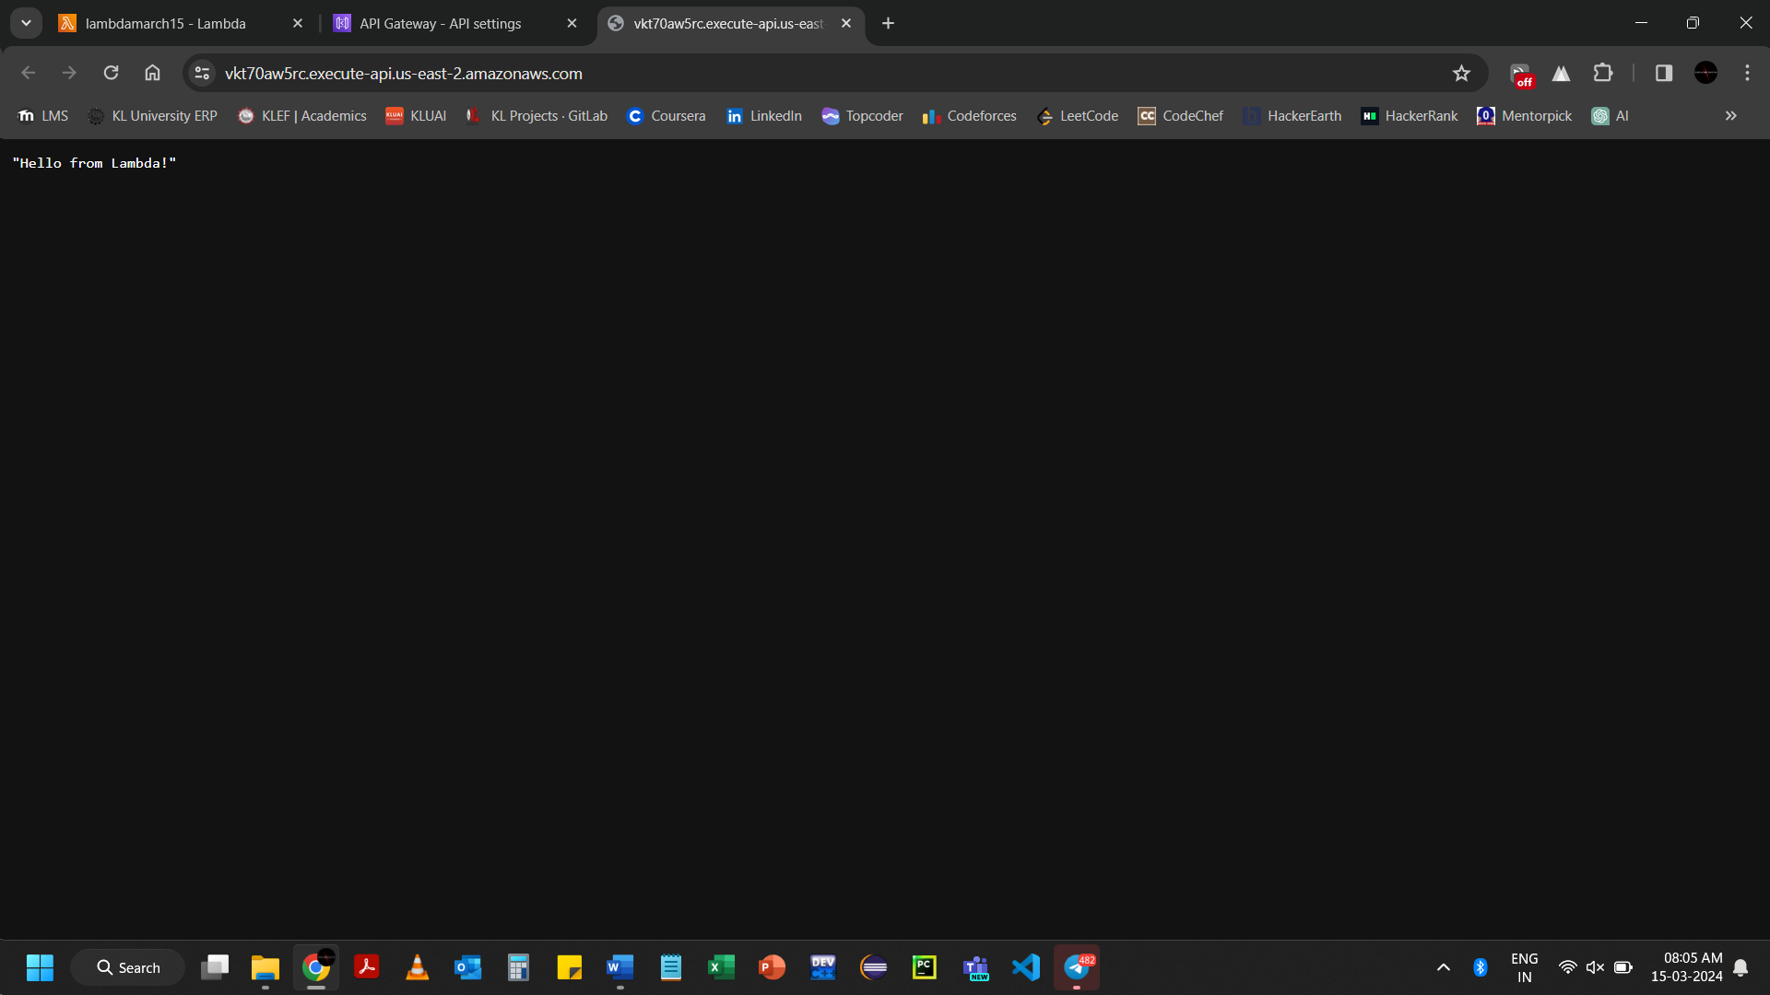

import json

def lambda_handler(event, context):

if event['rawPath'] == '/':

message = "Welcome to home page"

elif event['rawPath'] == '/guest':

message = "Welcome to guest page"

elif event['rawPath'] == '/user':

name="klu"

message = f"Hello {name}!"

elif event['rawPath'] == '/admin':

message = "Hello admin!"

else:

return {

'statusCode': 404,

'body': json.dumps({'message': 'Not found'})

}

return {

'statusCode': 200,

'headers': {

'Content-Type': 'application/json'

},

'body': json.dumps({'message': message})

}

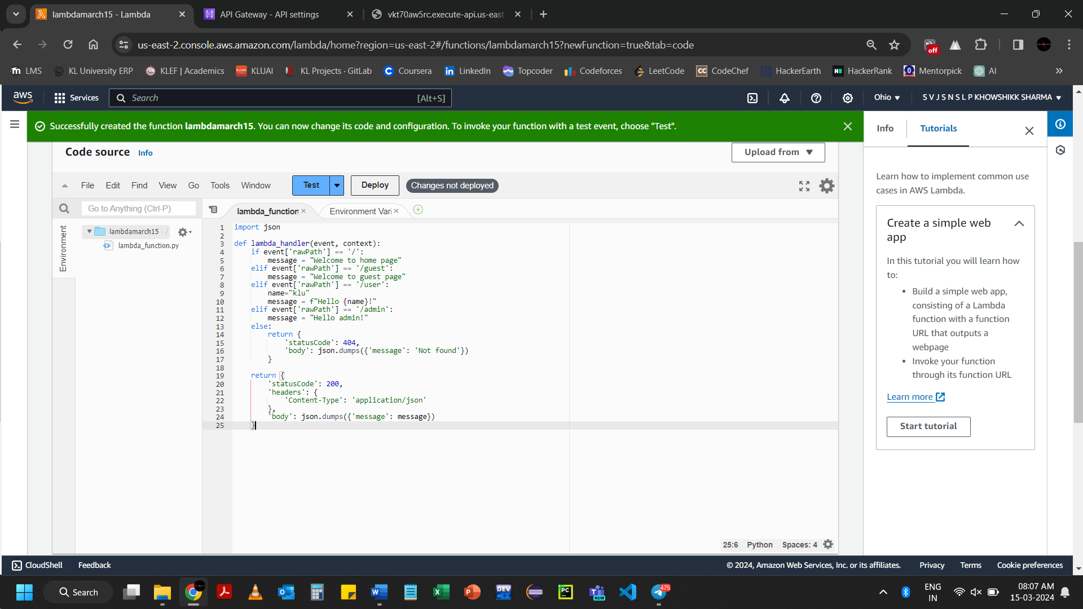Click on Deploy

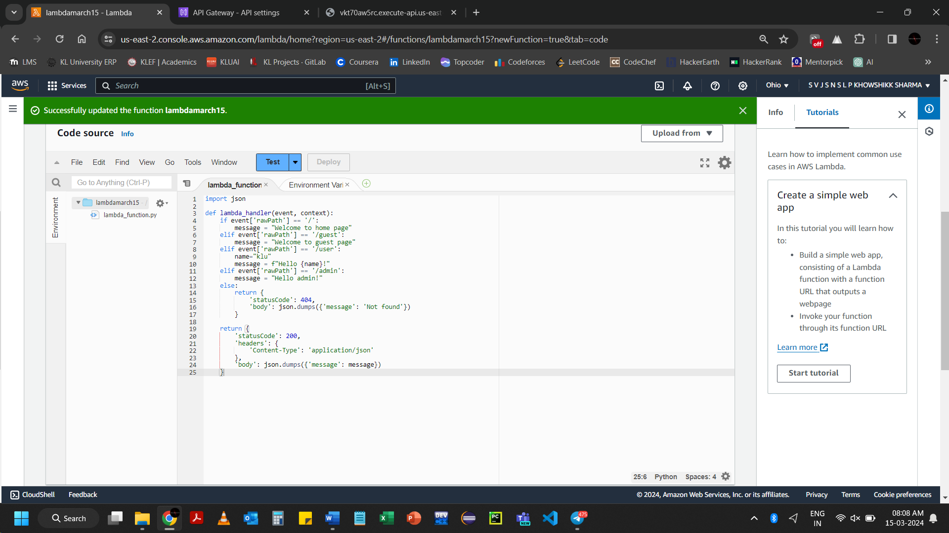

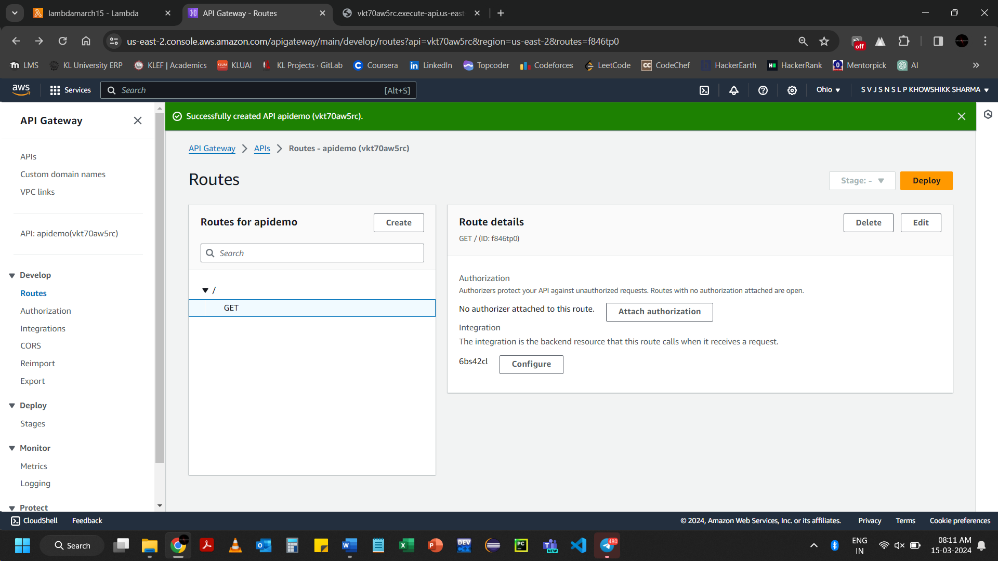

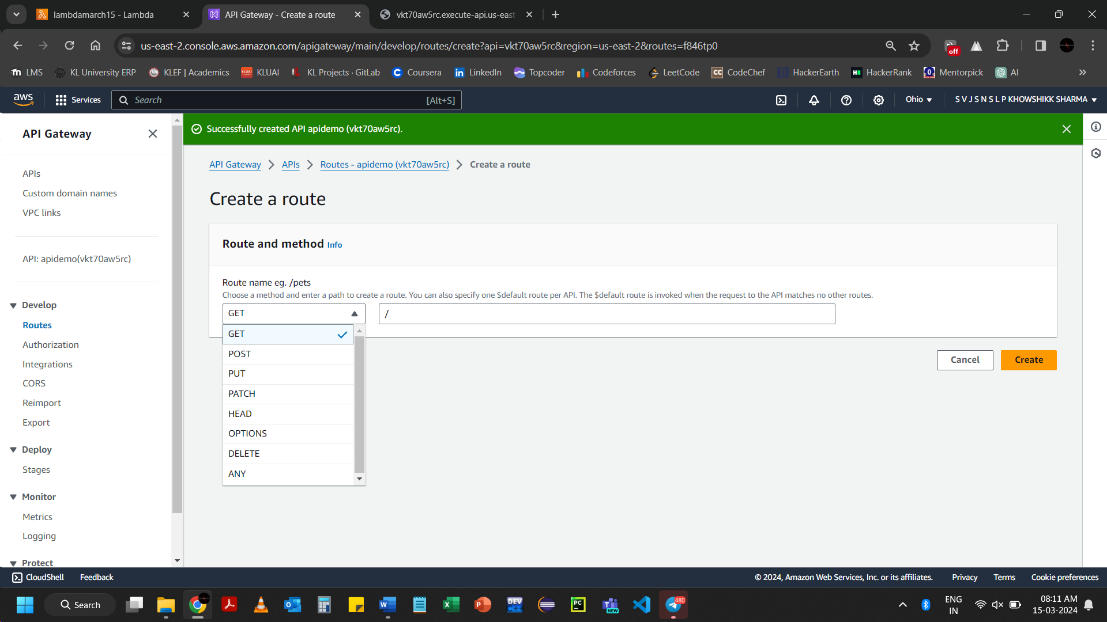

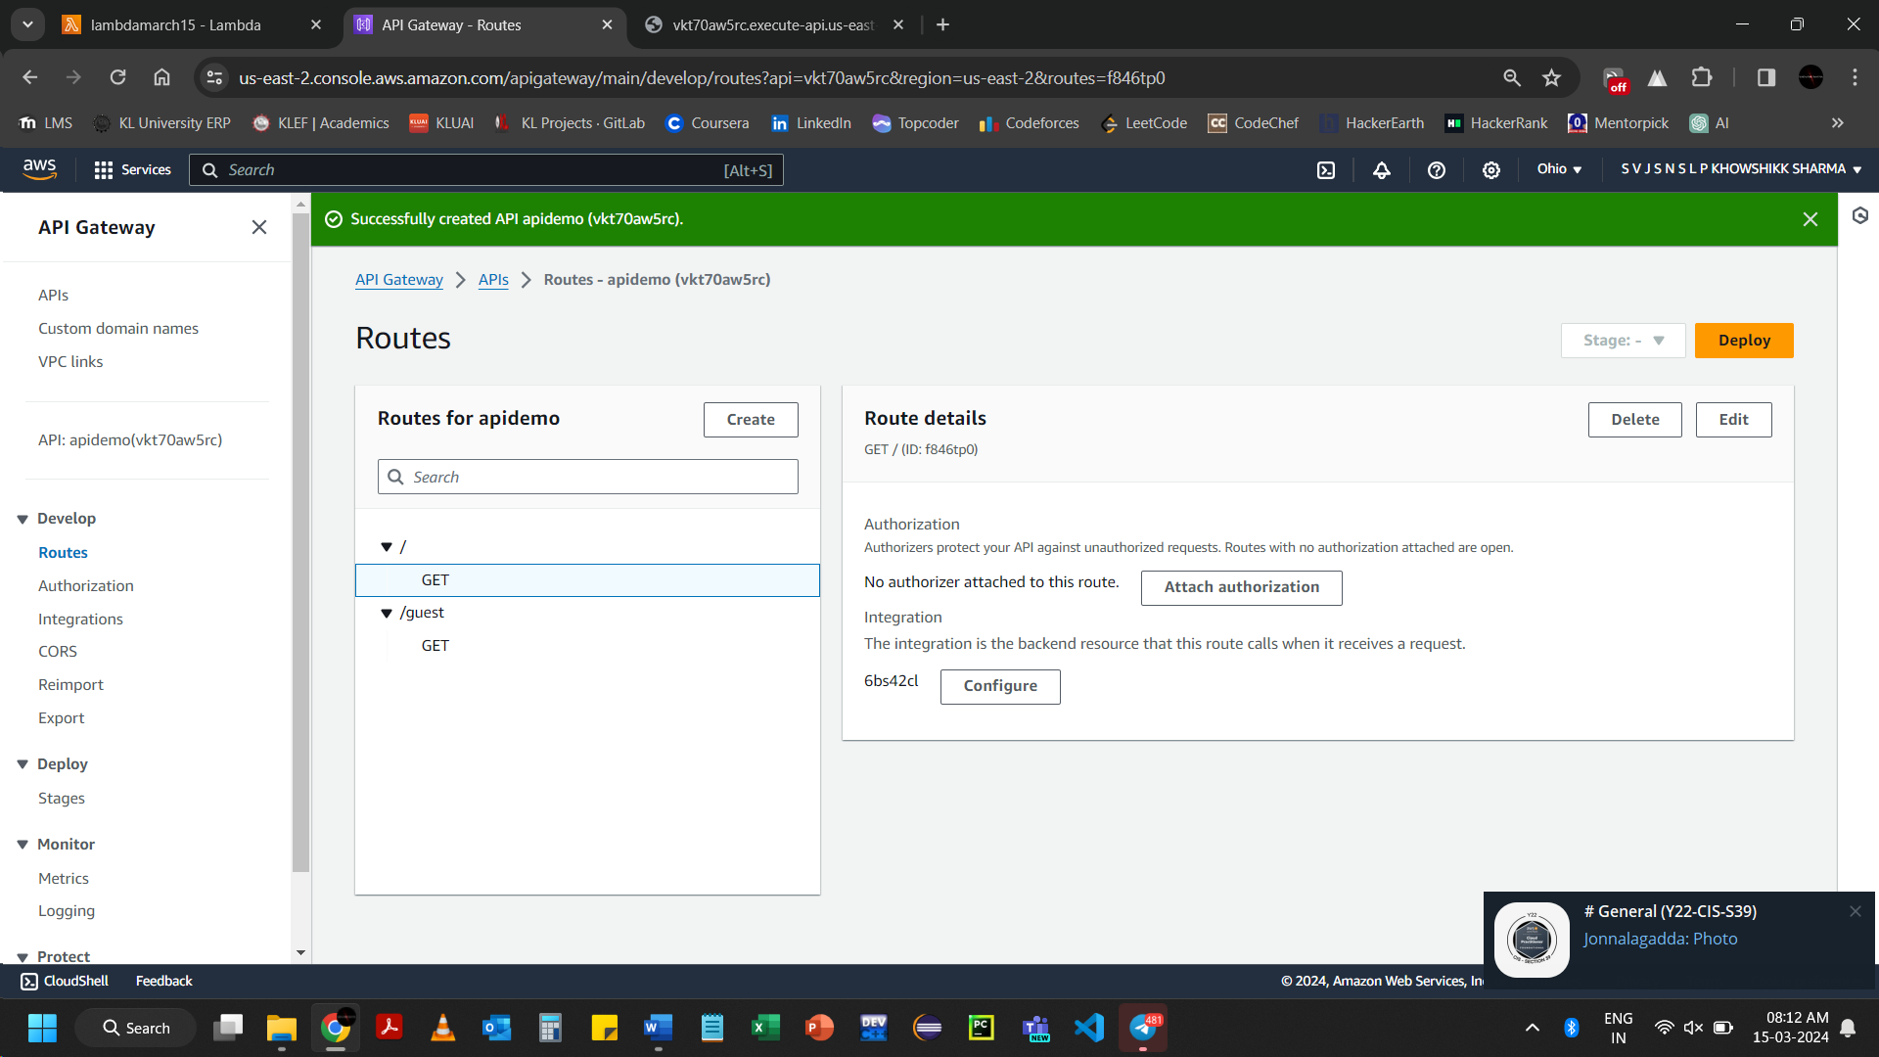Click on GET 🡪 Attach authorization

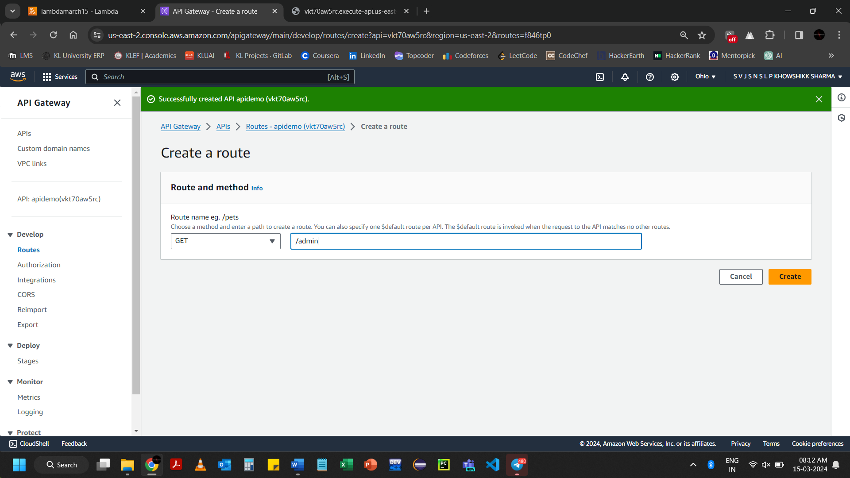Click on Create

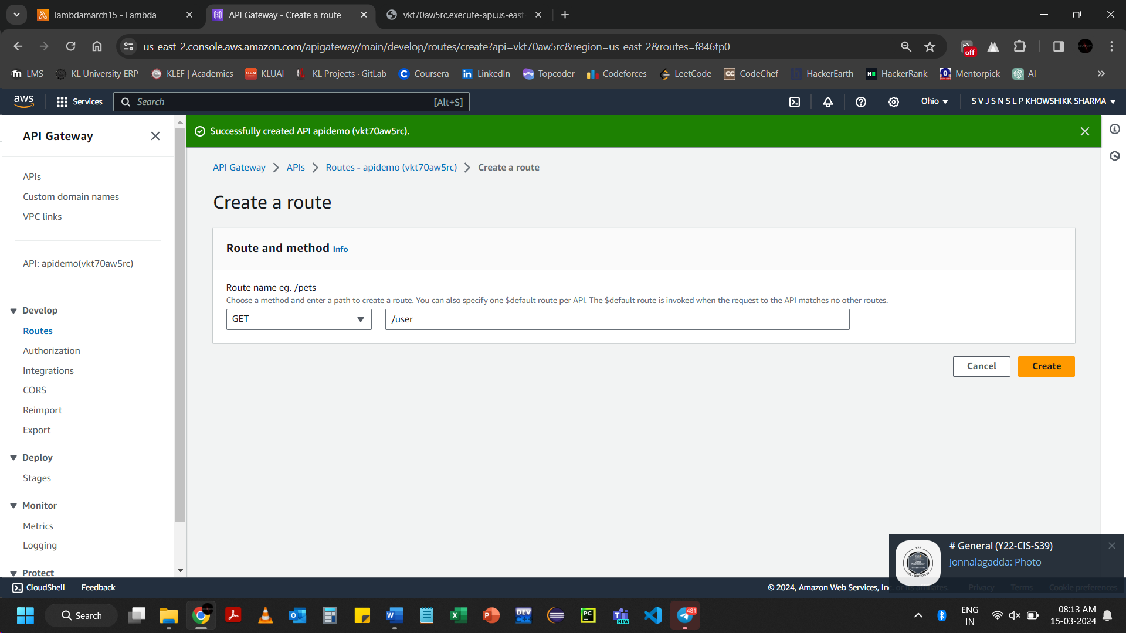 Click on Create

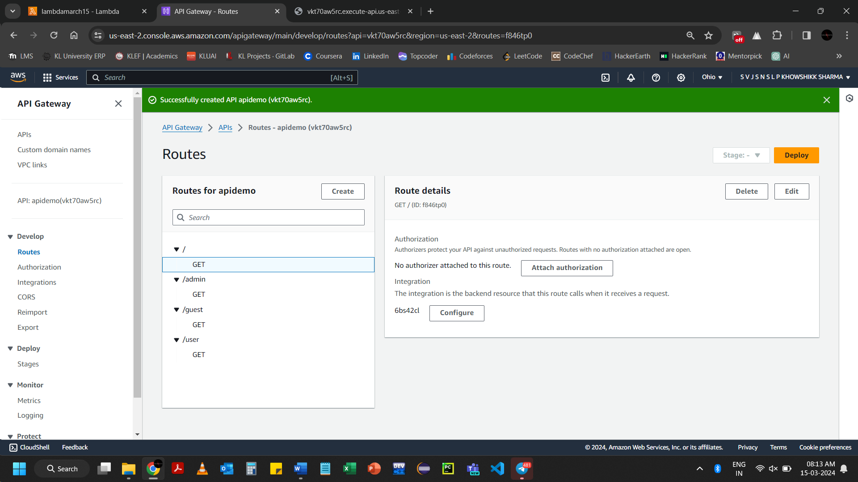

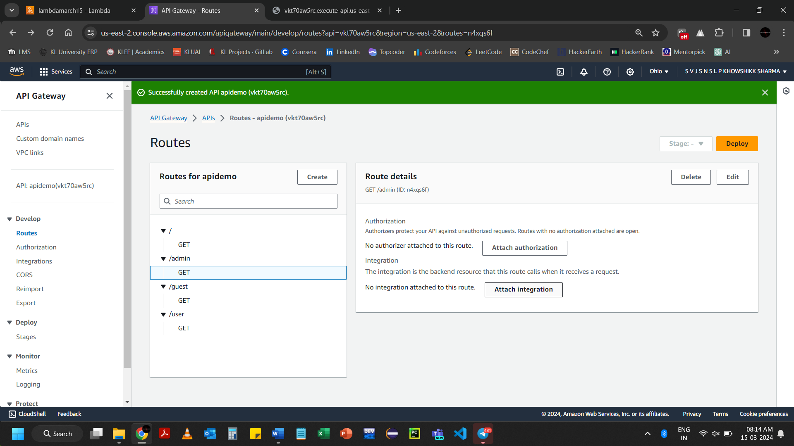Click on Attach integration

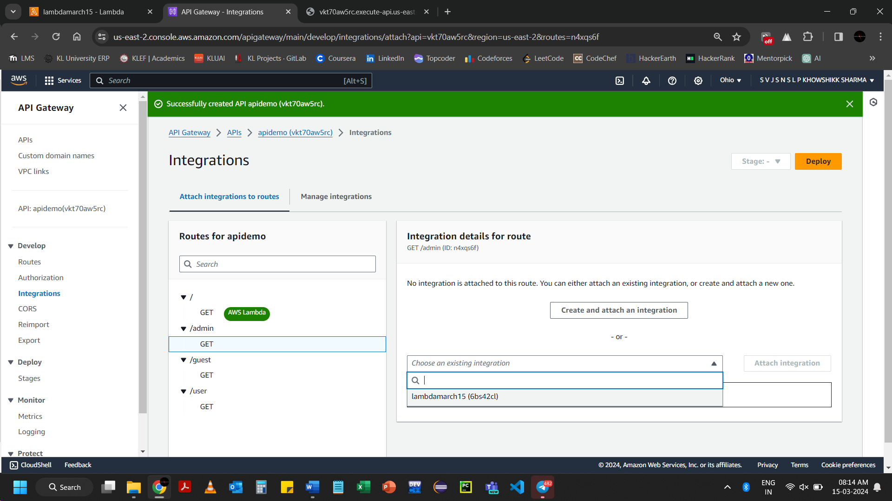

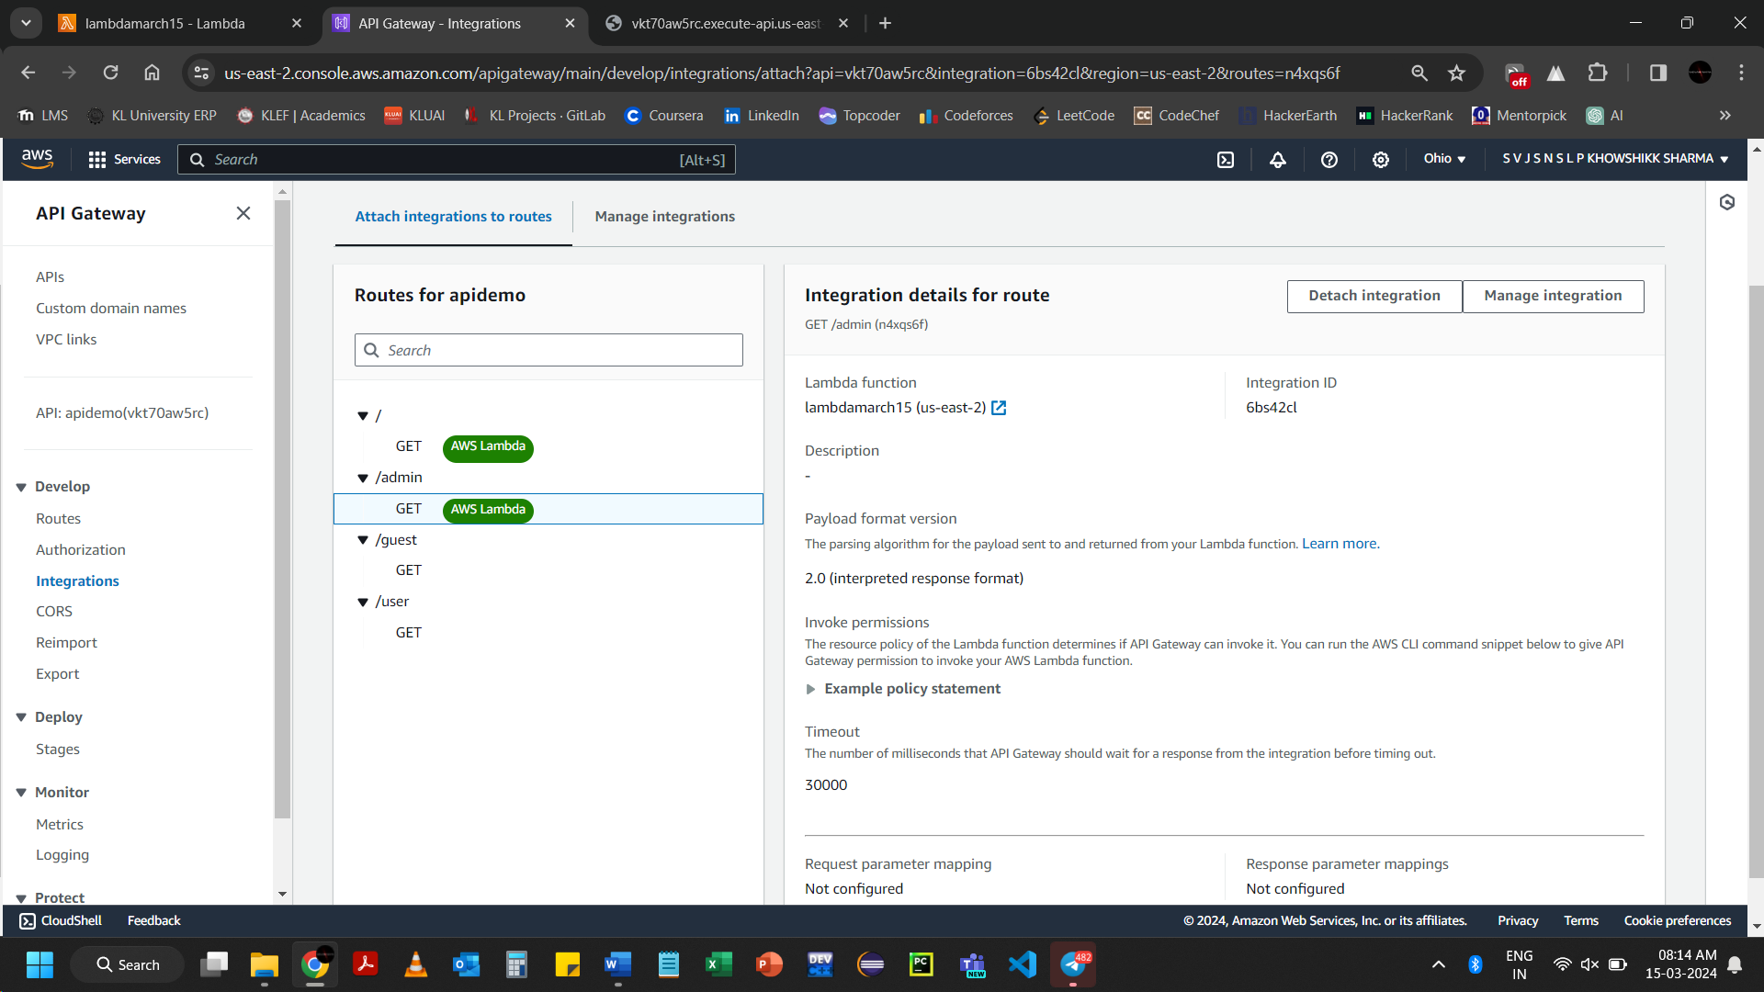

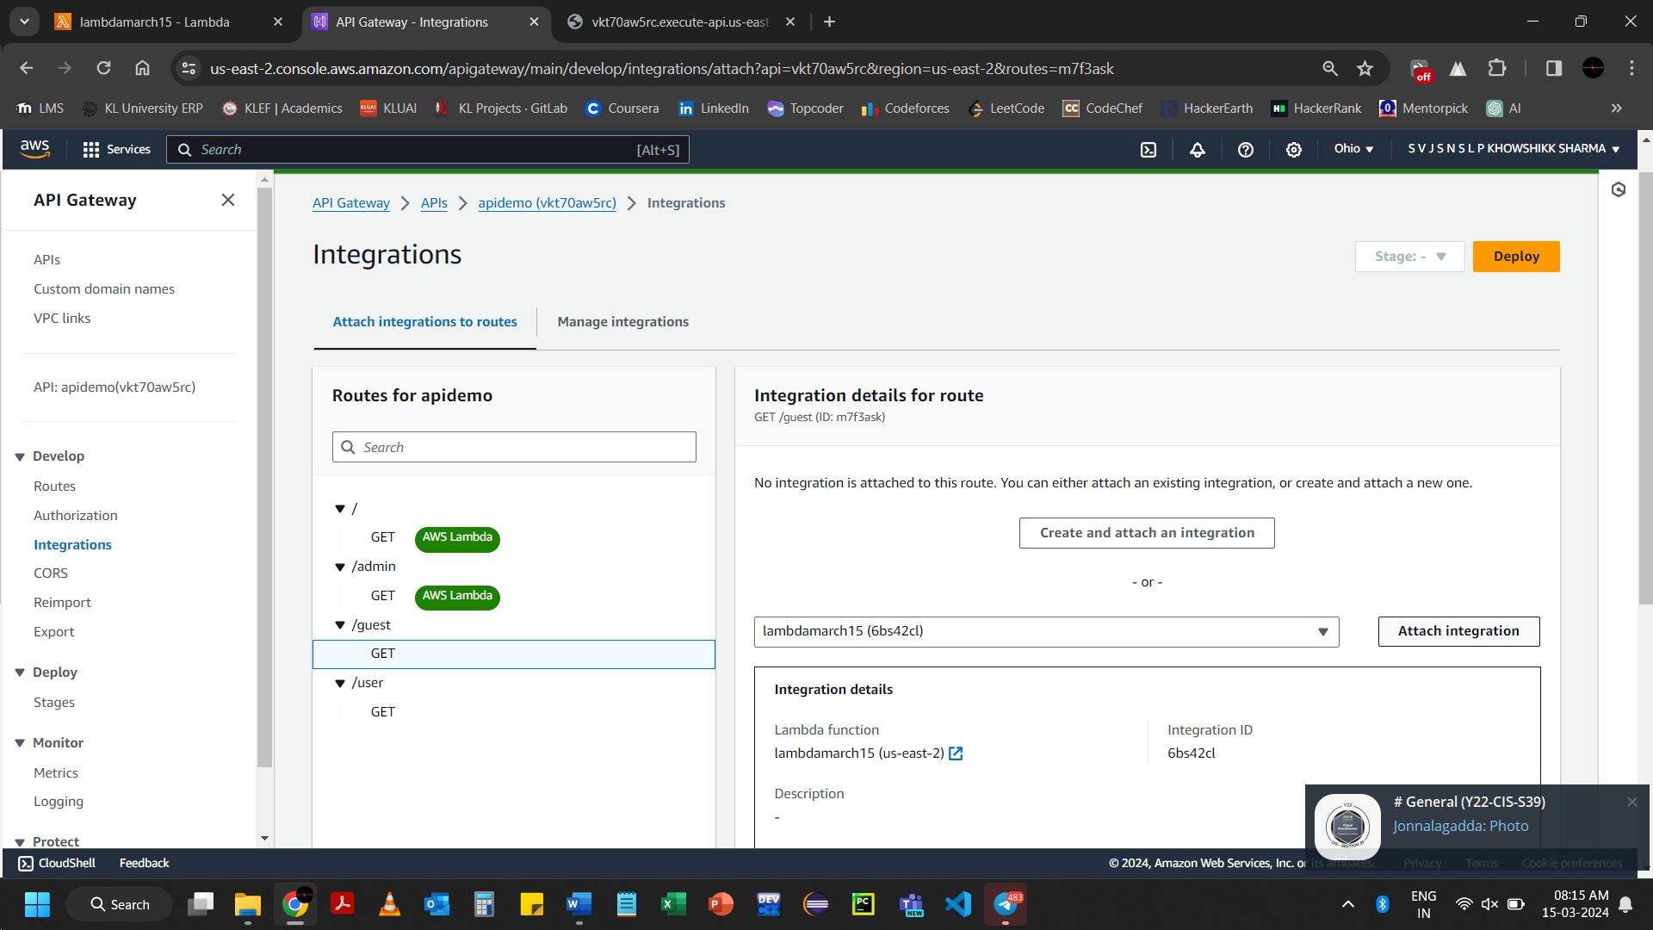

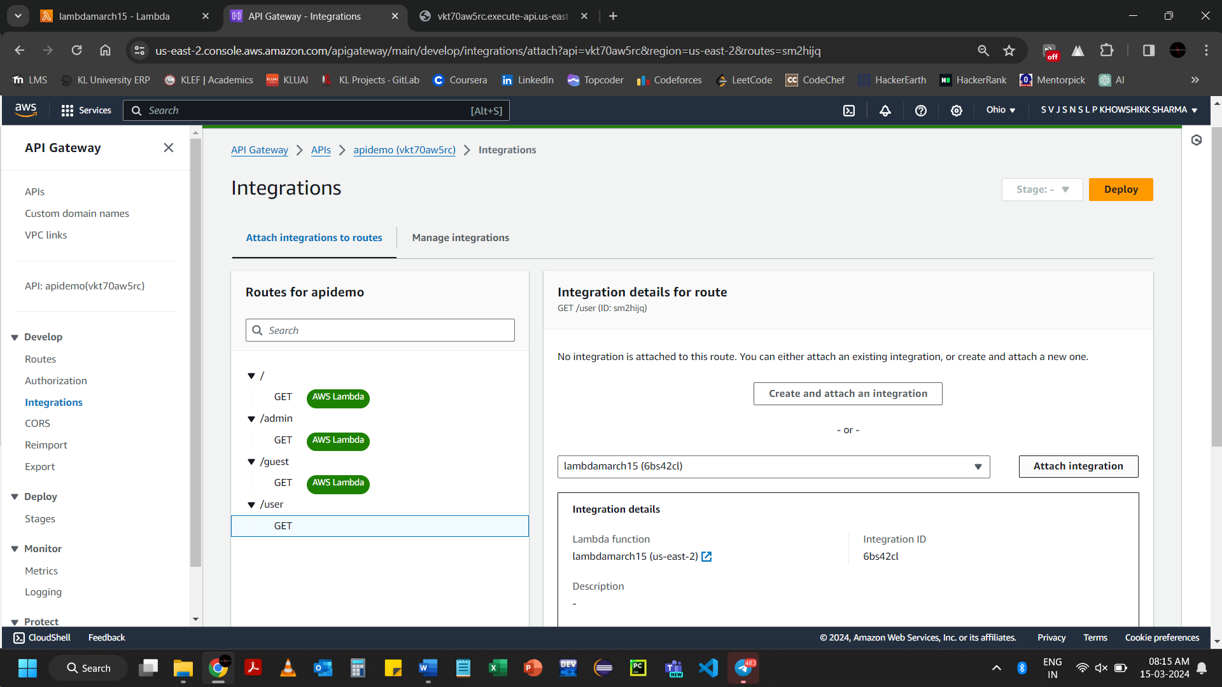

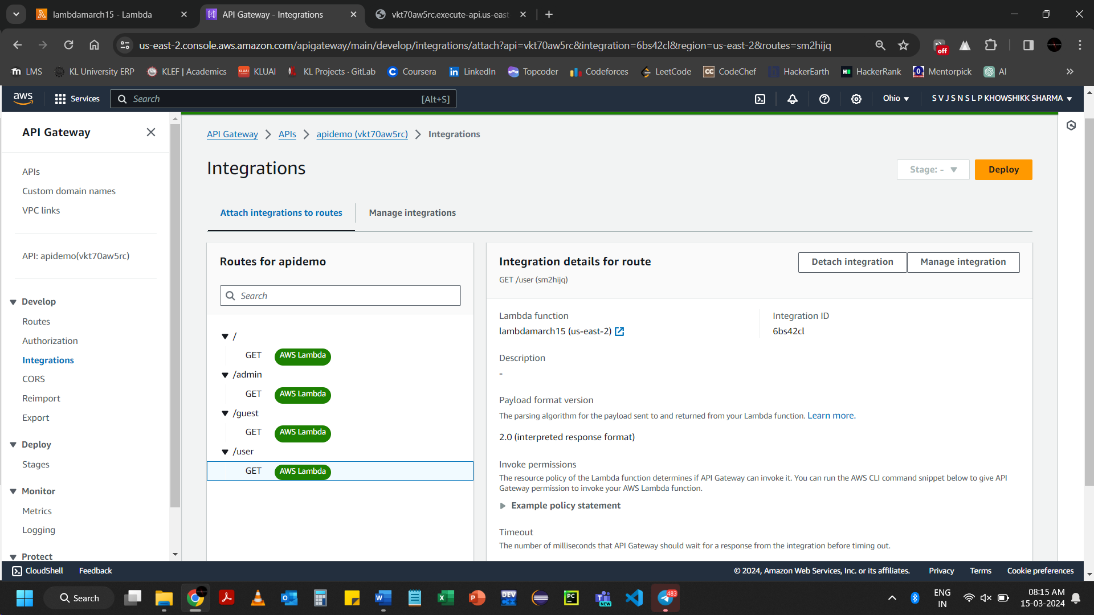

[https://vkt70aw5rc.execute-api.us-east-2.amazonaws.com/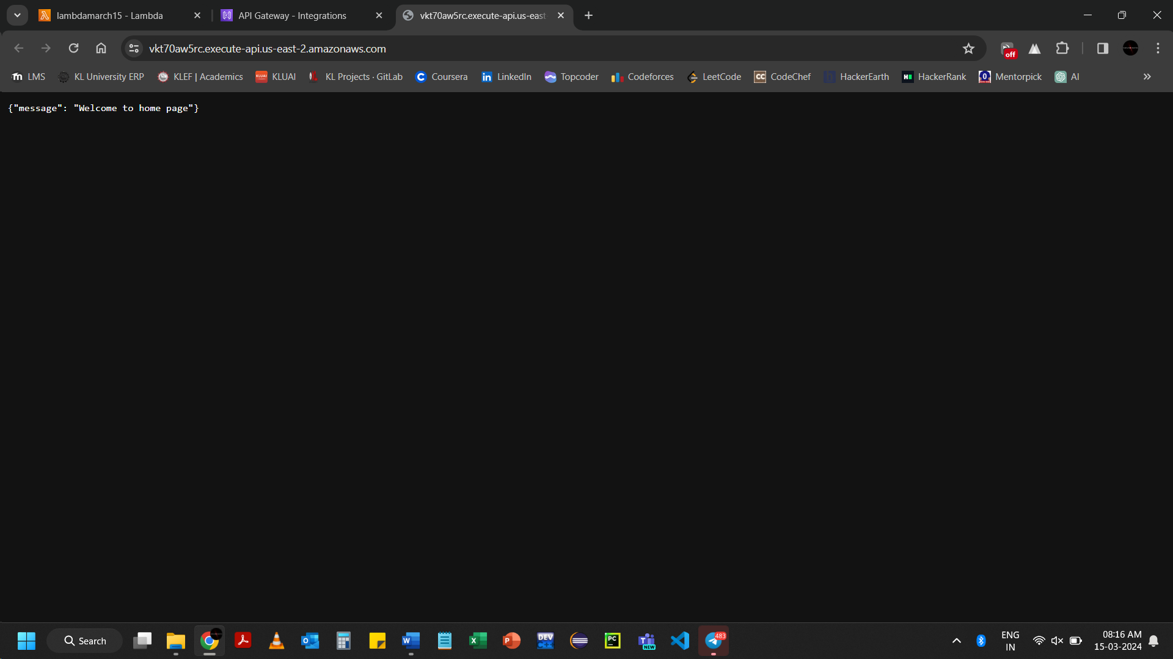](https://vkt70aw5rc.execute-api.us-east-2.amazonaws.com/)

[https://vkt70aw5rc.execute-api.us-east-2.amazonaws.com/user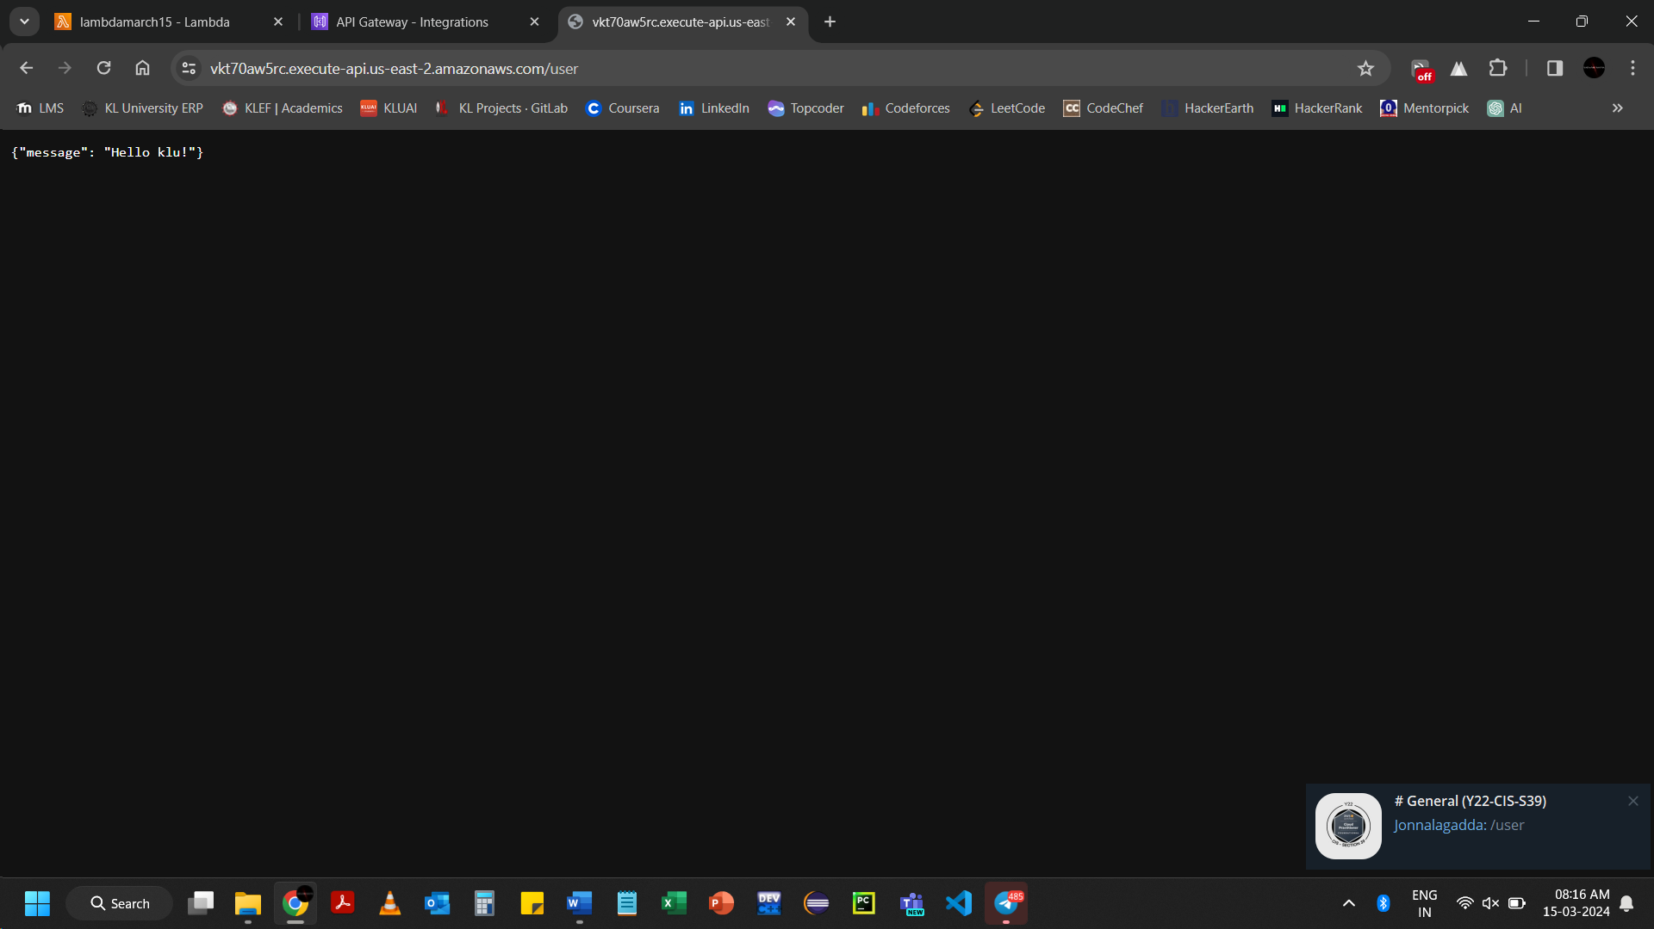](https://vkt70aw5rc.execute-api.us-east-2.amazonaws.com/user)

<https://vkt70aw5rc.execute-api.us-east-2.amazonaws.com/admin>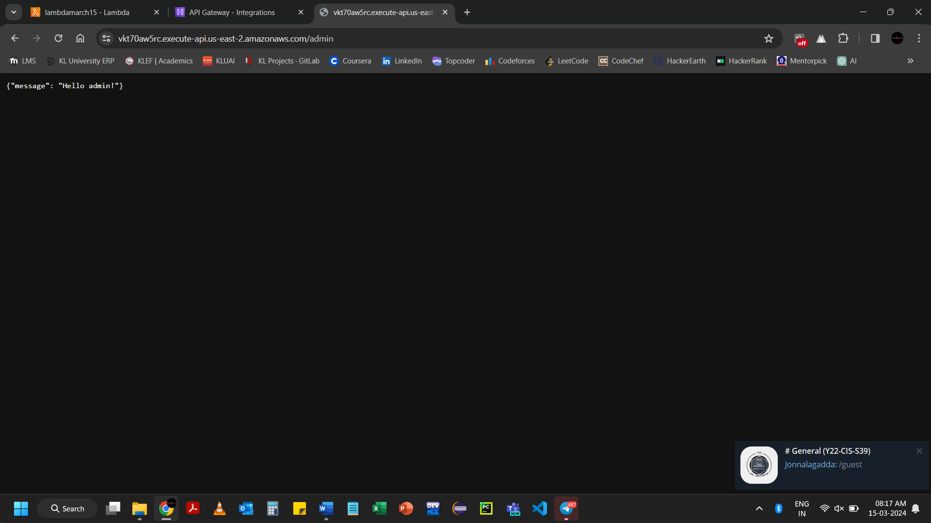

[https://vkt70aw5rc.execute-api.us-east-2.amazonaws.com/guest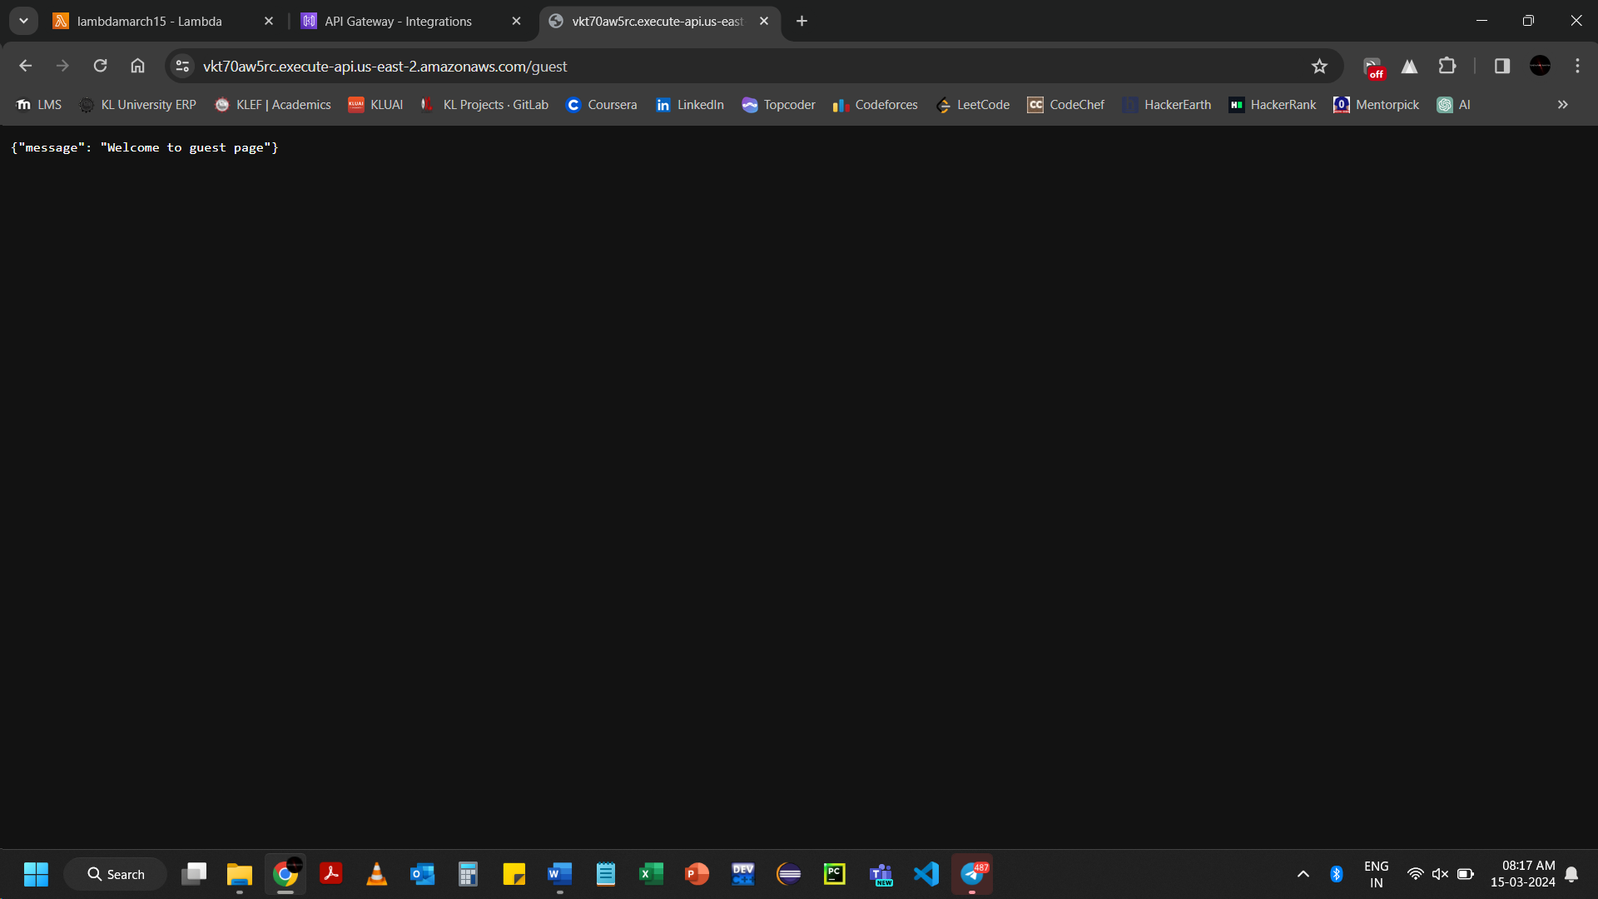](https://vkt70aw5rc.execute-api.us-east-2.amazonaws.com/guest)

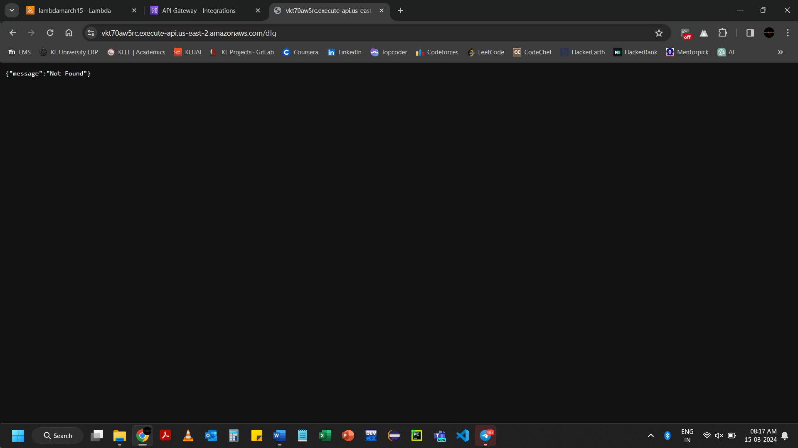

import json

def lambda_handler(event, context):

if event['rawPath'] == '/':

message = "Welcome to home page"

elif event['rawPath'] == '/guest':

message = "Welcome to guest page"

elif event['rawPath'] == '/user':

name="klu"

message = f"Hello {name}!"

elif event['rawPath'] == '/admin':

message = "Hello admin!"

elif event['rawPath'] == '/emp': //newly added for checking Json format

message = {"id":2200031954, "name":"khowshikk sharma", "age":19}

else:

return {

'statusCode': 404,

'body': json.dumps({'message': 'Not found'})

}

return {

'statusCode': 200,

'headers': {

'Content-Type': 'application/json'

},

'body': json.dumps({'message': message})

}

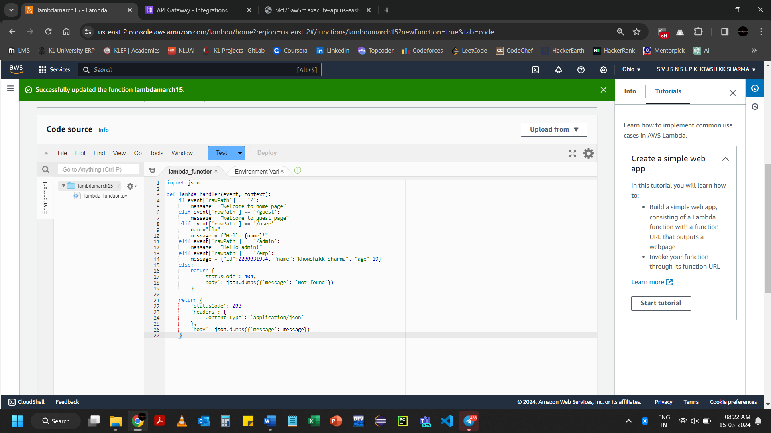

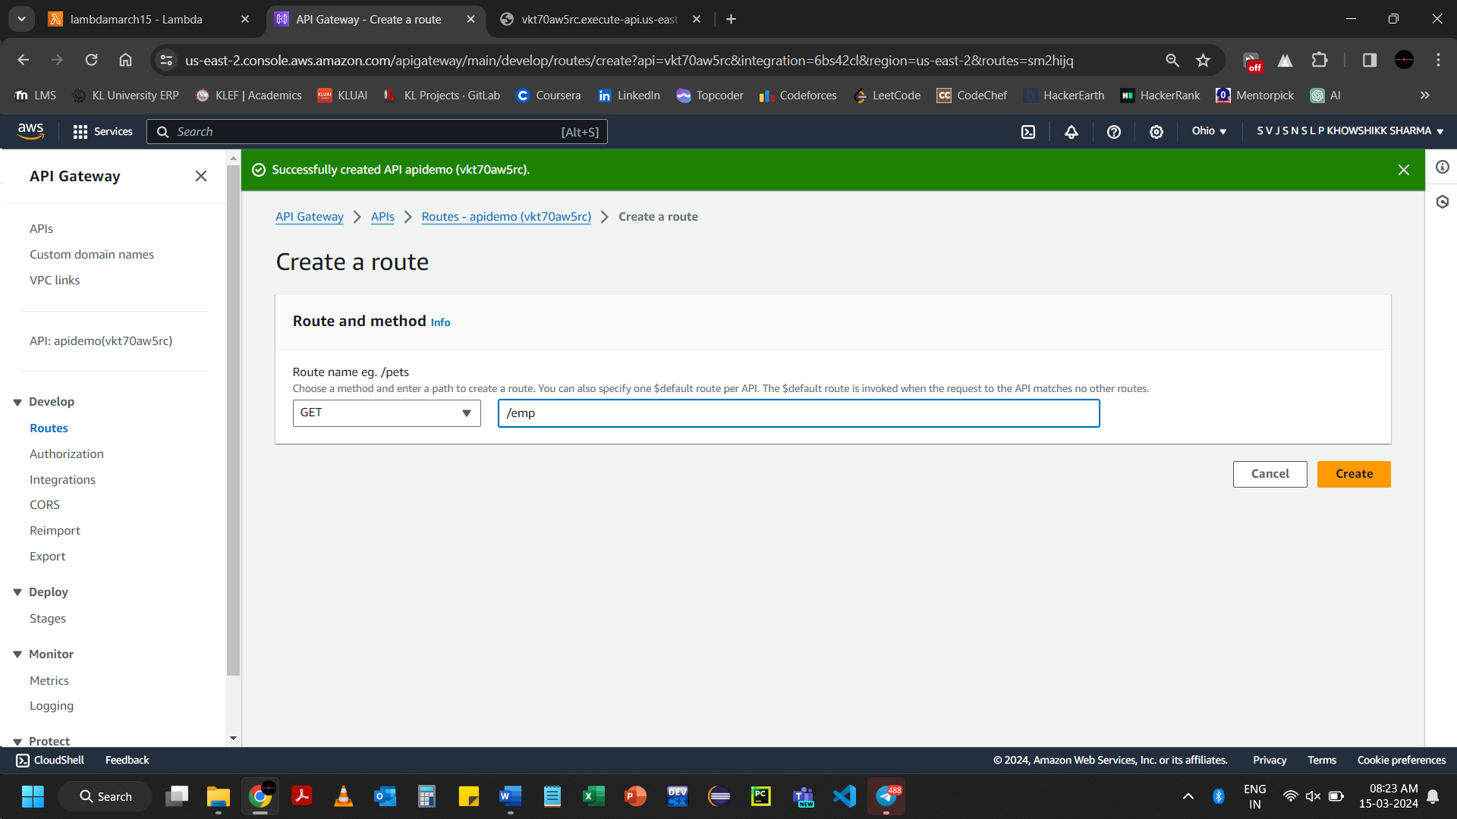

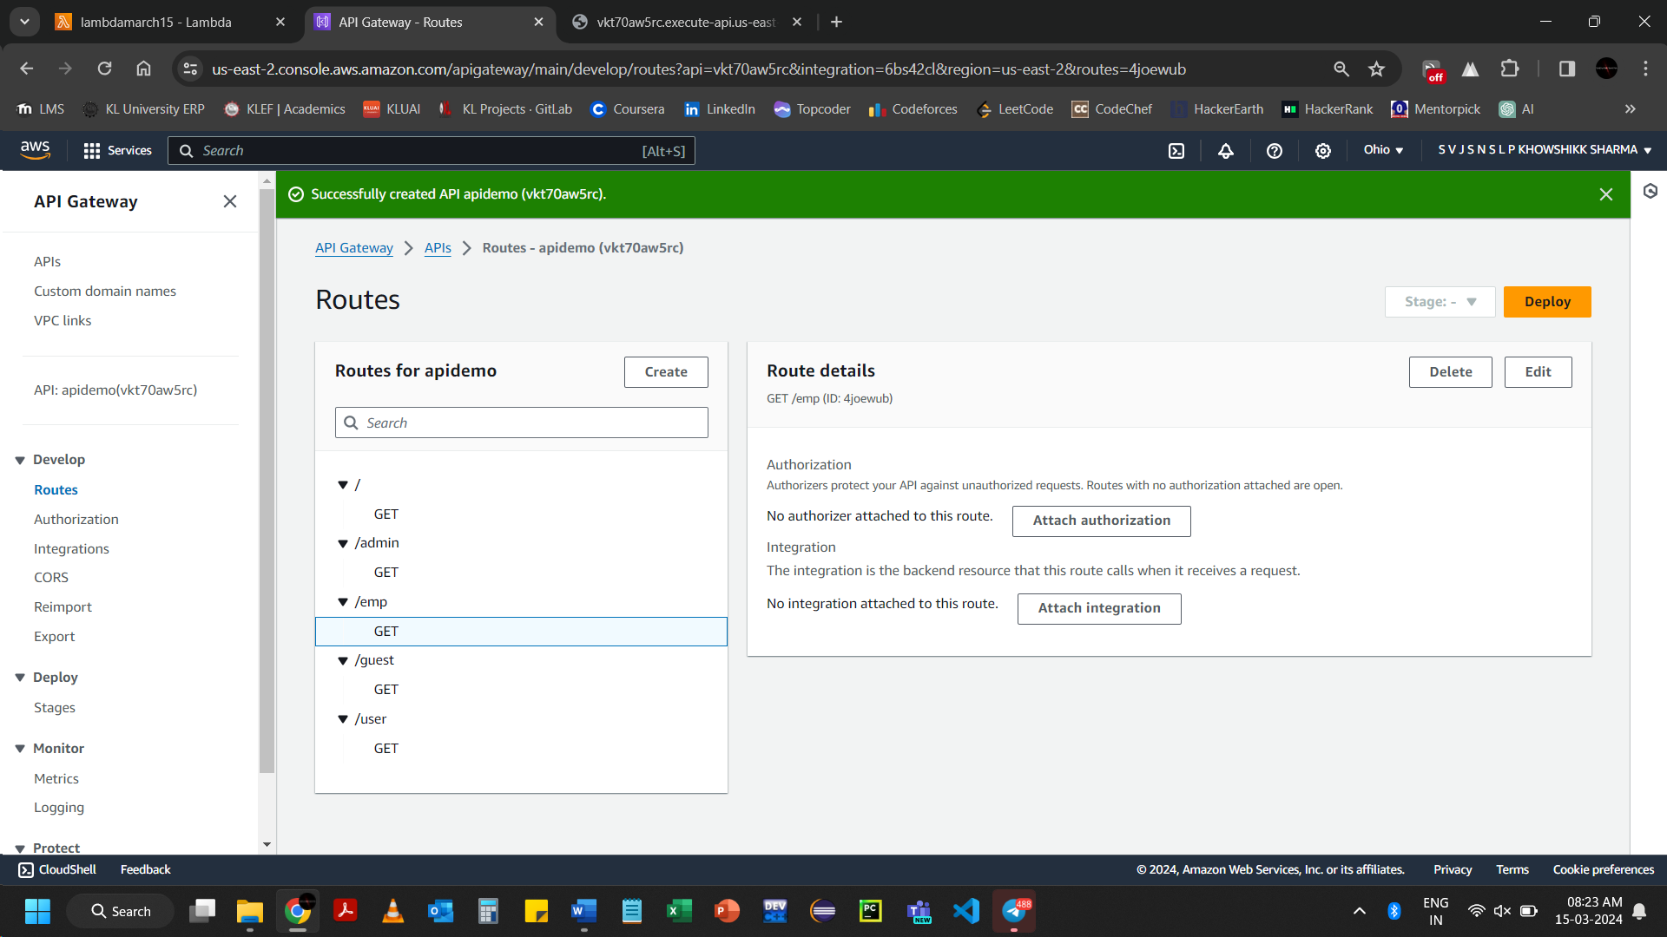

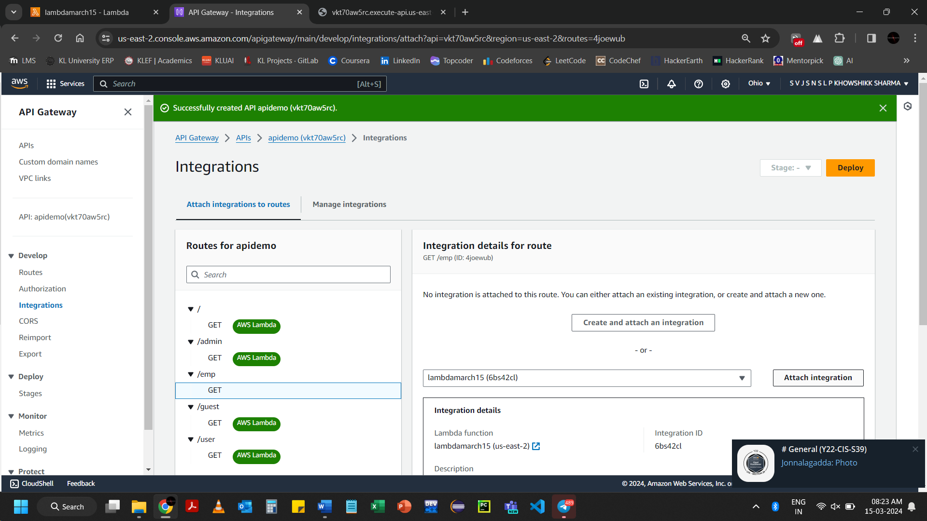

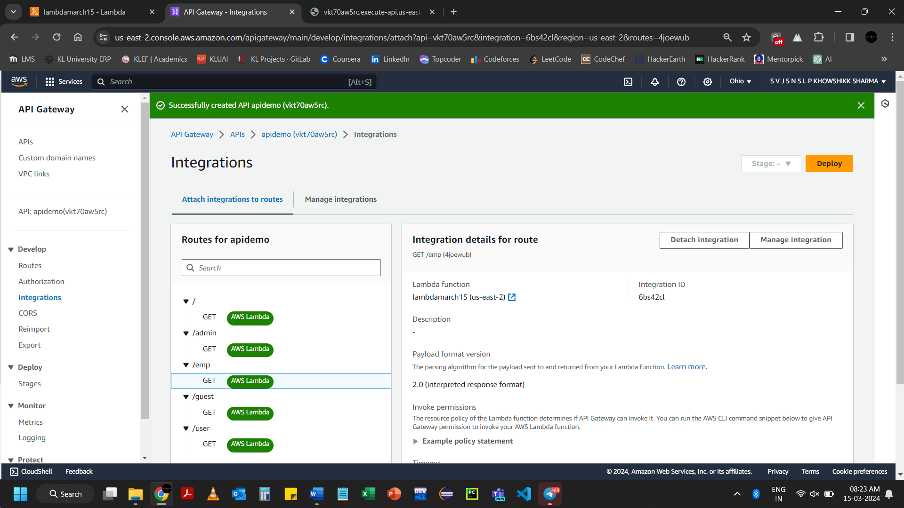

[https://vkt70aw5rc.execute-api.us-east-2.amazonaws.com/emp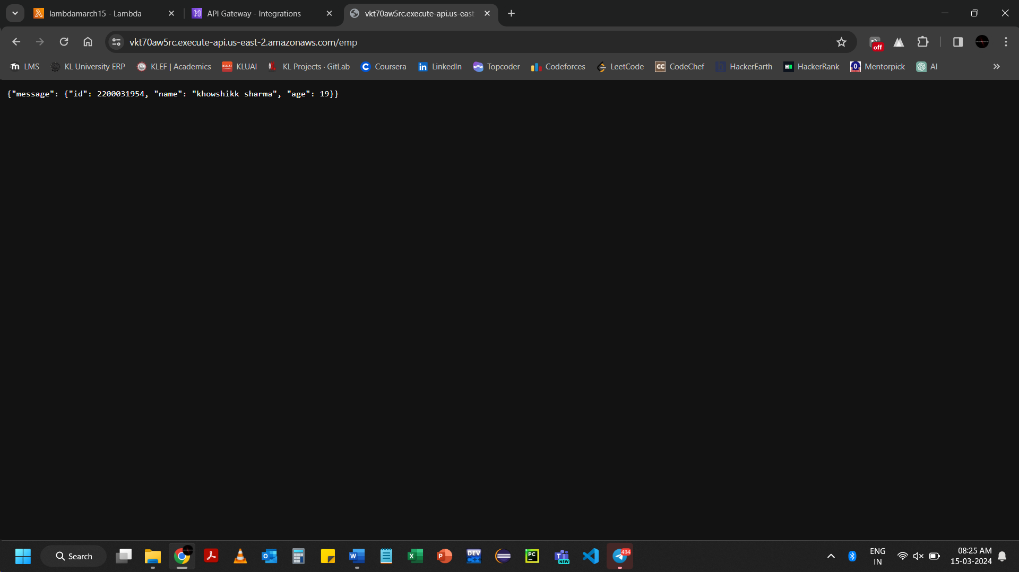](https://vkt70aw5rc.execute-api.us-east-2.amazonaws.com/emp)

Deleting the Lab

Deleting the APIs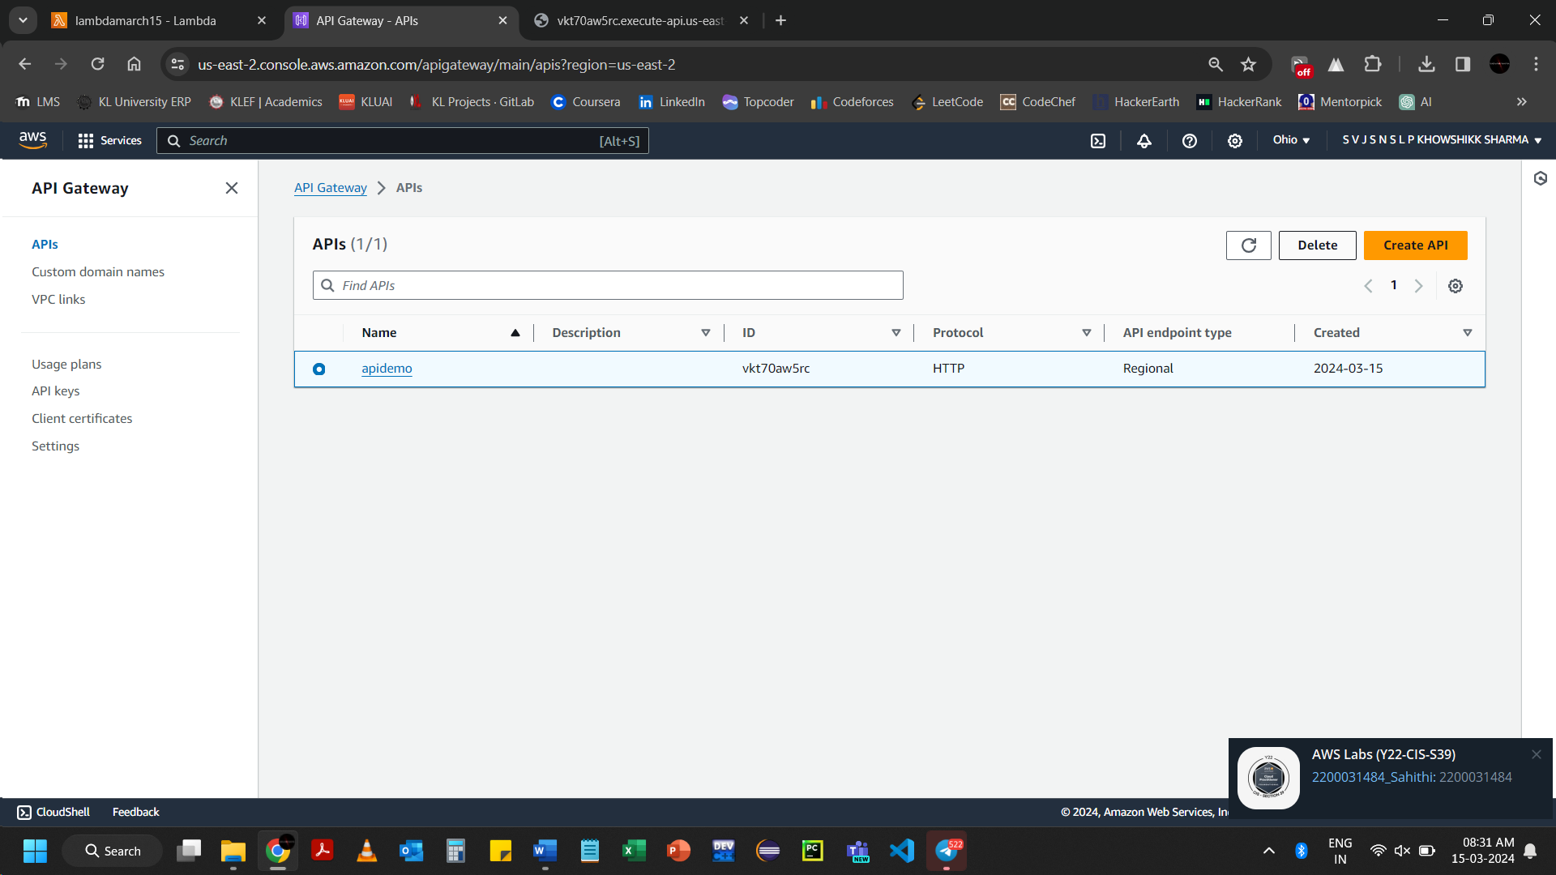 Select the required API 🡪 Click on Delete

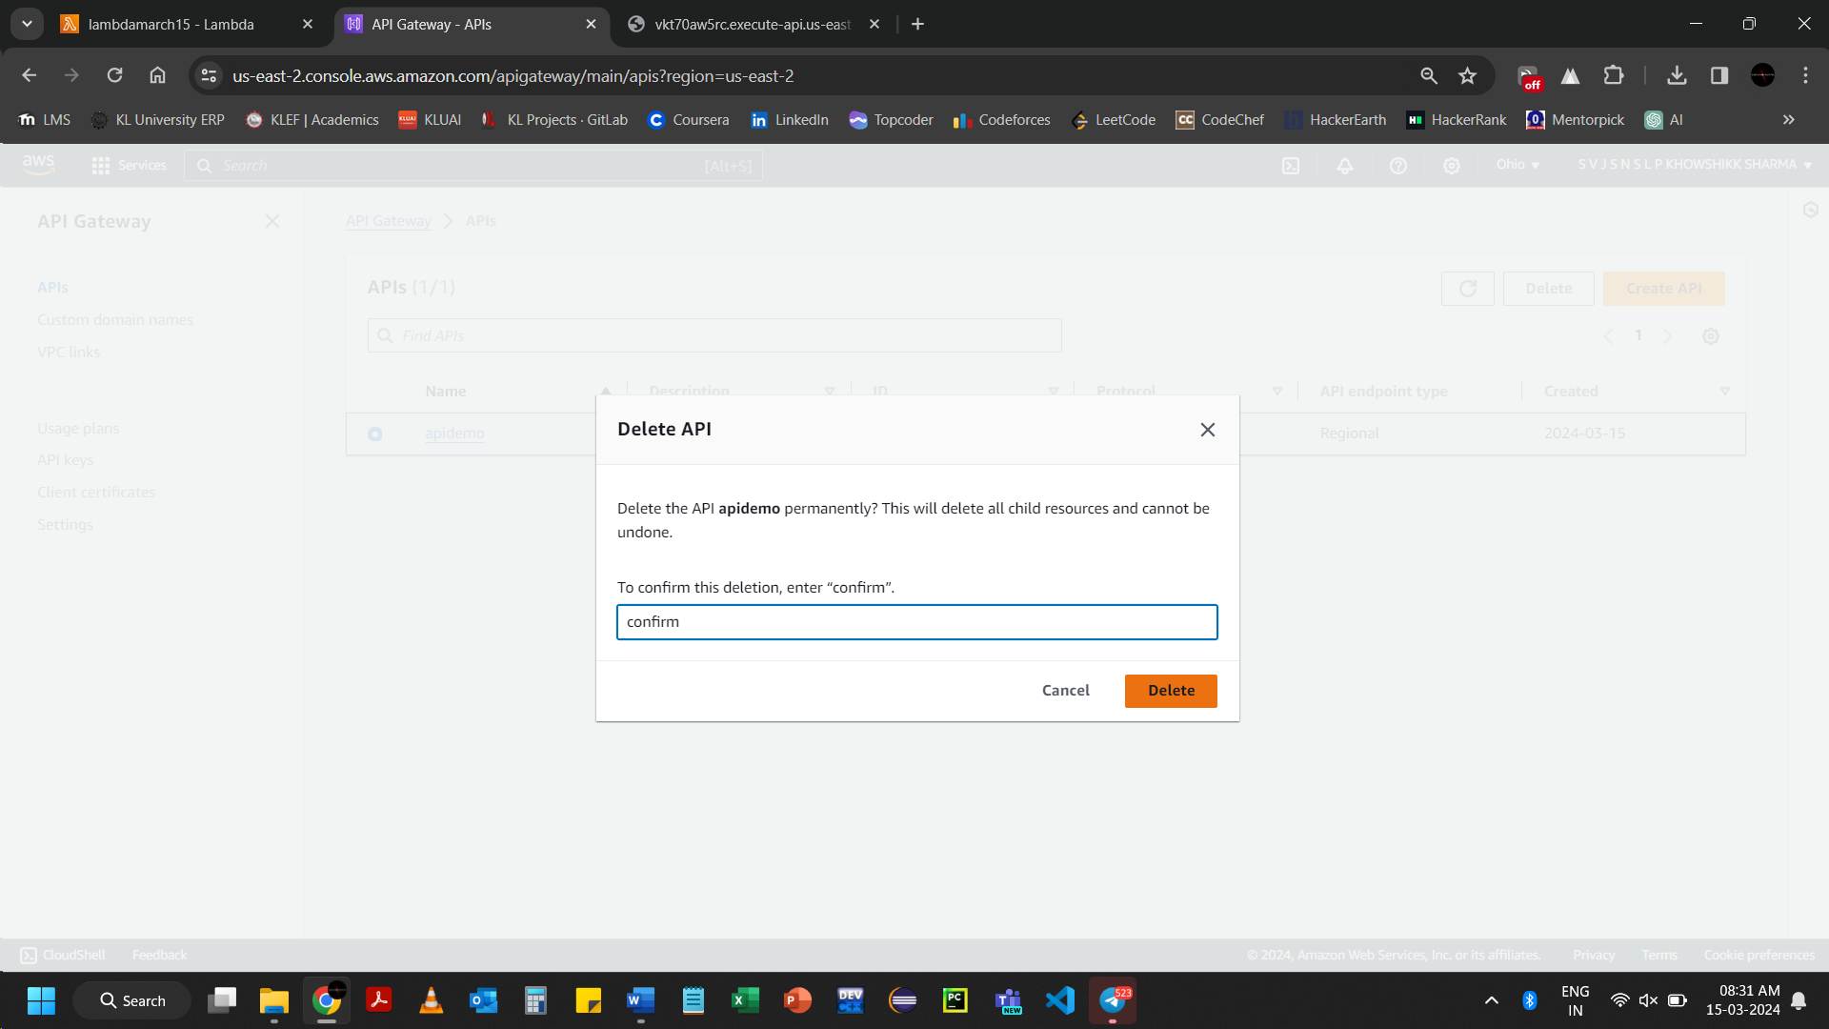Click on Delete

Deleting the Lambda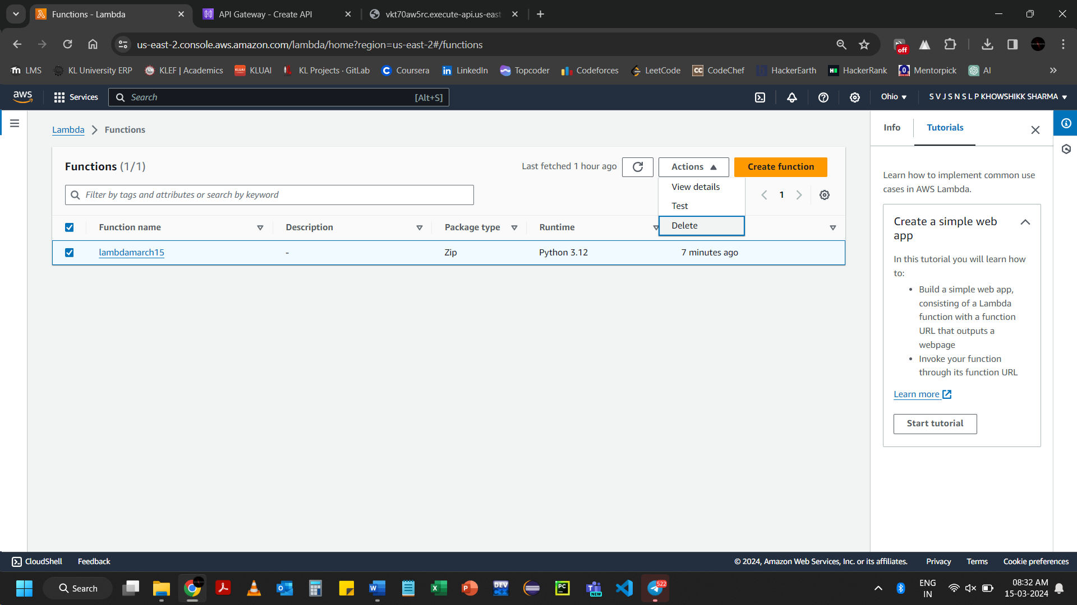 Select the required Functions 🡪 Click on Delete

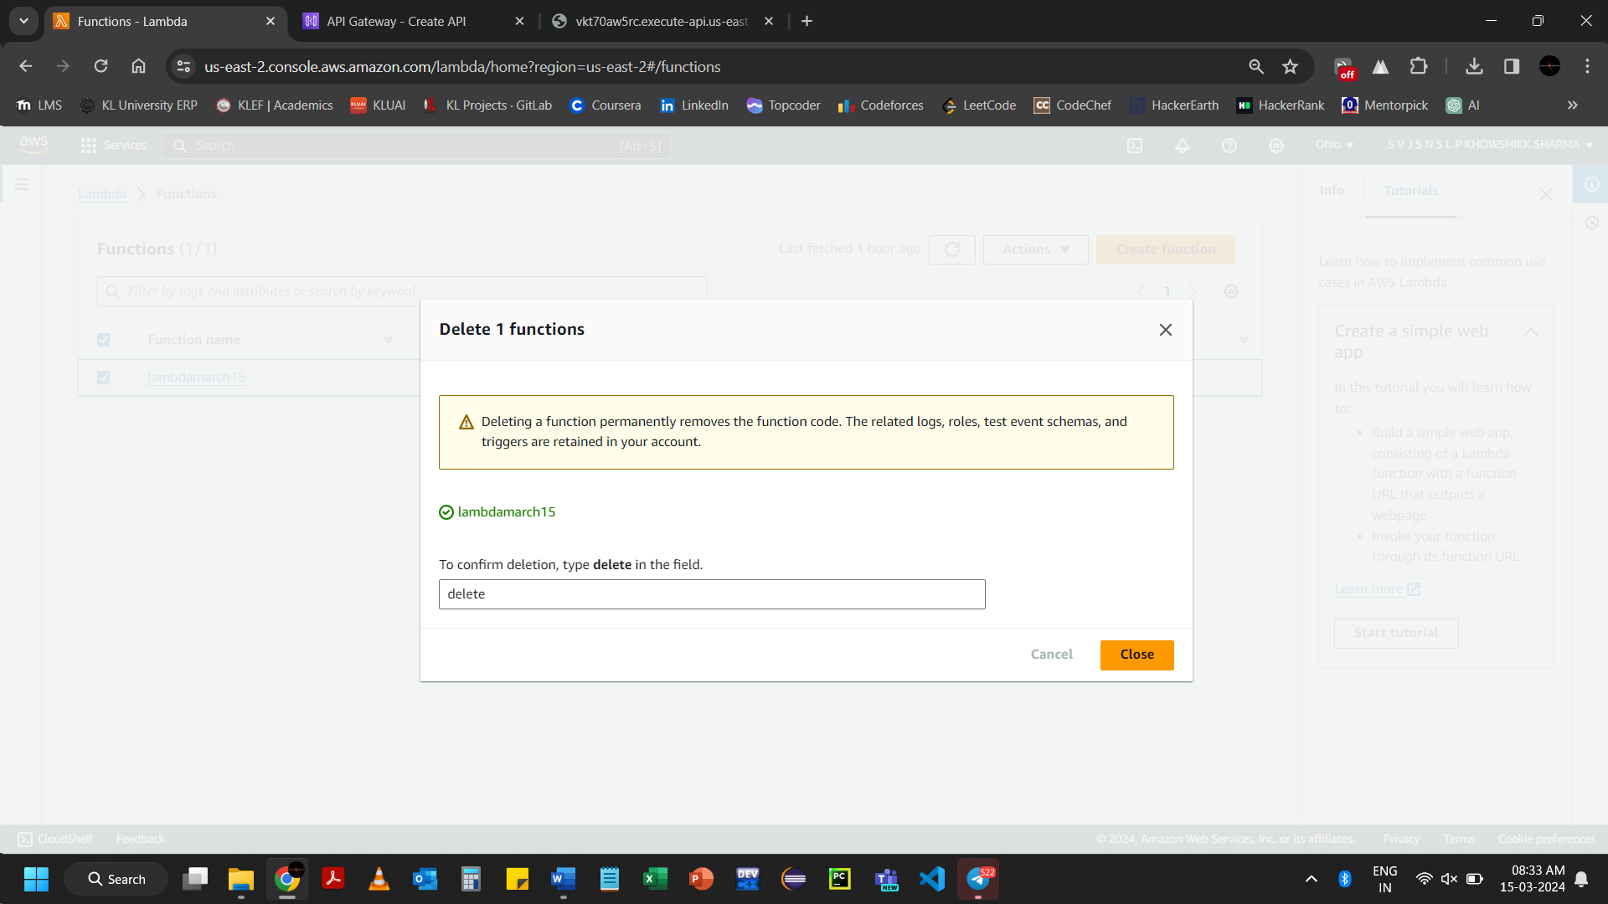Click on Close

